Autumn 1 | Autumn 2 |  | Spring 1 |  | Spring 2 |  | Summer 1 |  | Summer 2
Vicious Vikings?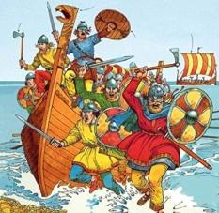 |  | Let There Be Light  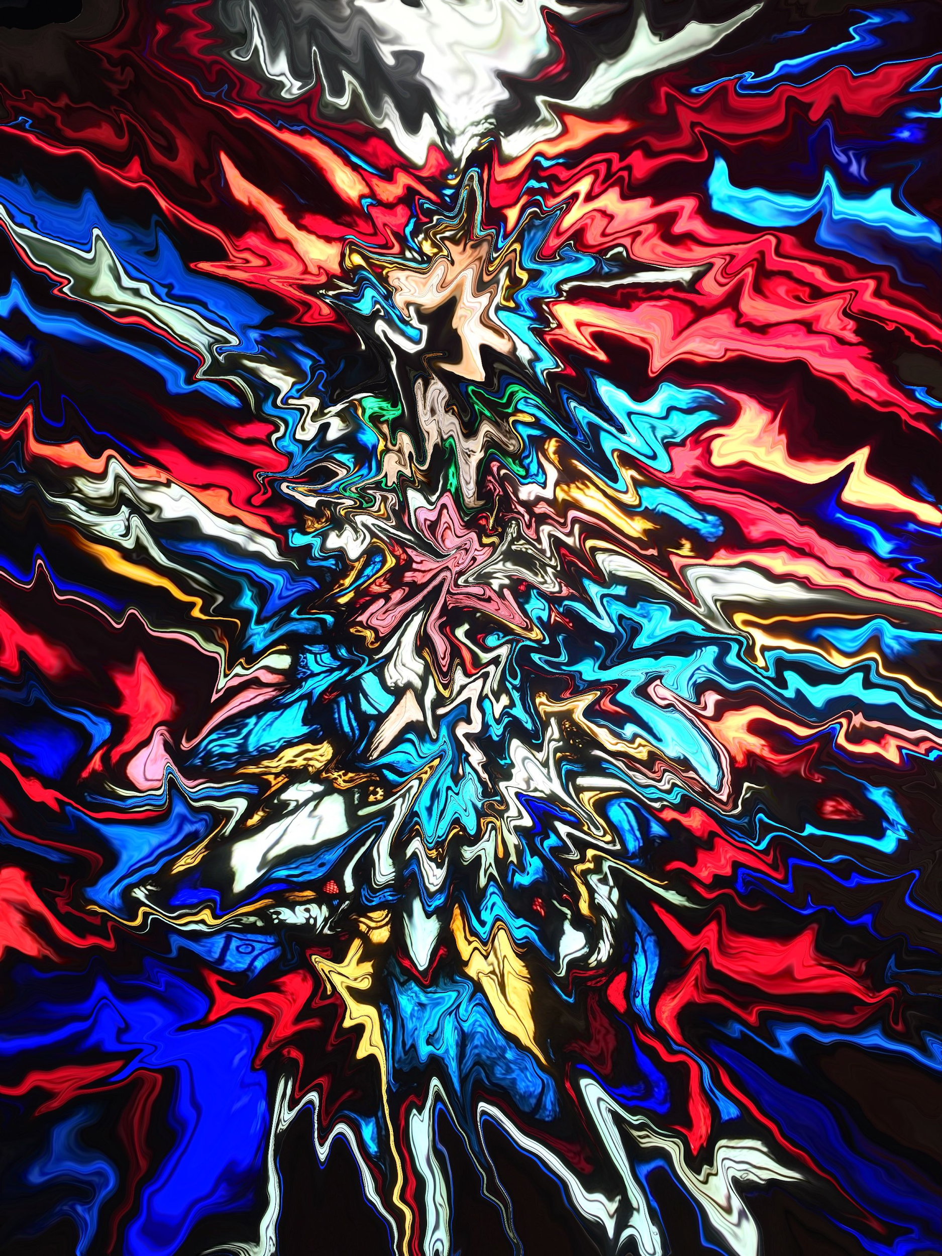 |  | Exploring the Alps  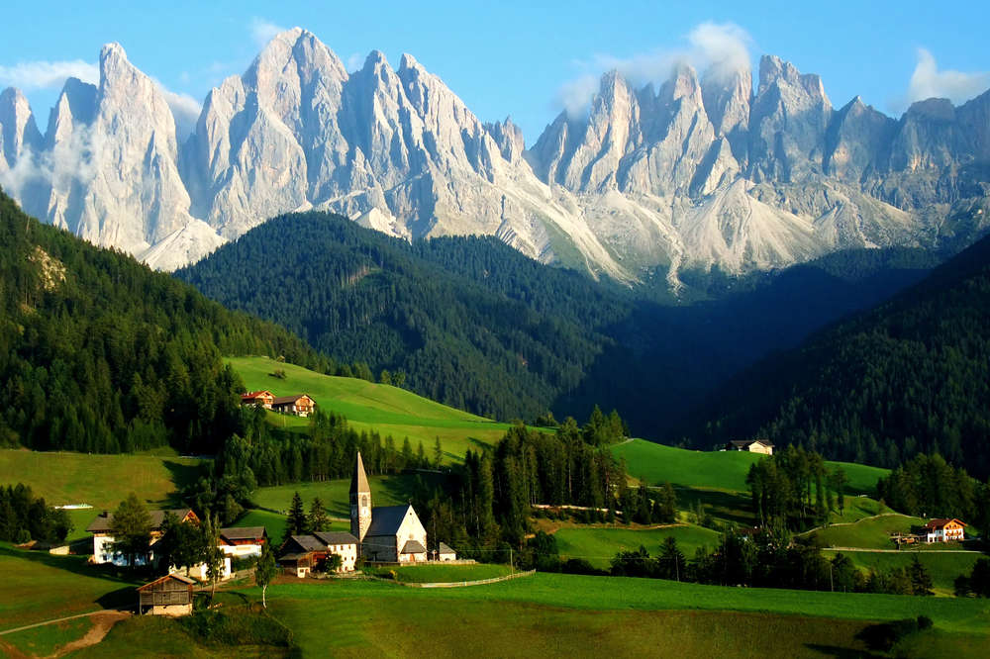 |  | Witney – Place in Time  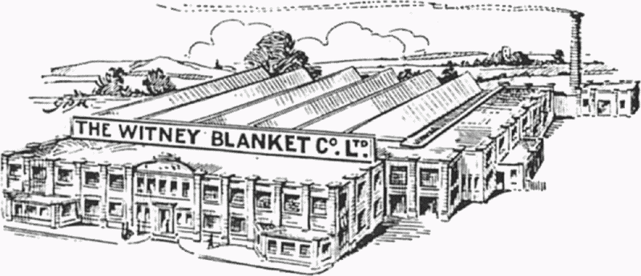 |  | Coasts  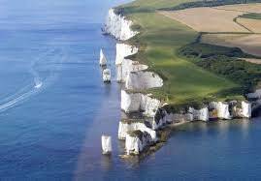
Subject Focus  History: Were the Vikings really vicious?; Anglo-Saxons & Vikings – struggle for power; trade in Viking times. |  | Subject Focus  RE: Incarnation; symbolism of light in different religions. UC 2b.4 – Was Jesus the Messiah? |  | Subject Focus  Geography: Region of Europe: weather including seasonal change and how this relates to location; mountains in UK and Europe (compare and contrast); tourism. |  | Subject Focus  History: Local study; link to theme of trade (textiles).  Geography: Local study with fieldwork (textile trade). |  | Subject Focus  Geography: Coastal features and processes; coastal settlements; fieldwork.
Linked Learning  Geography: Mapping UK and Europe; coasts vocab.  DT: Viking longships (joining wood to make strong framework; finishing techniques; evaluation). |  | Linked Learning  Science: Light  Art and Design: Create stained glass windows (different techniques; link to artist study – who?)  Computing: Use graphics software to design patterns from tessellated and rotated shapes. |  | Linked Learning  Science: States of matter; forces; electricity.  DT: Design and make ski lifts.  Art and Design: Use of space and perspective in landscapes.  MFL: Greetings in Alpine languages; French unit on weather.  Computing: Create and interrogate databases of mountains and settlements in the Alps and other mountain ranges; create interactive web page map of key locations in the Alps. |  | Linked Learning  DT: Design and create class blanket, knitting squares.  Art and Design: Use of perspective in pictures of buildings.  Computing: Use spreadsheet software to explore and present key data from our enquiries. |  | Linked Learning  History: Trade by sea.  Science: Classification, food chains, changing habitats; evolution.  Computing: Stop motion animations of erosion.  Art and Design: Set design for performance of Treasure Island.  DT: Create props for performance of Treasure Island.
Text(s)  Odd and the Frost Giants by Neal Gaiman.  100 Facts: Vikings by Miles Kelly. |  | Text(s)  The Light Jar by Lisa Thompson *or* Skellig by David Almond.  FArTHER by Grahame Baker-Smith.  The Witness by Robert Westall.  (Remembrance: Dulce et Decorum Est by Wilfred Owen; Charge of the Light Brigade by Alfred Lord Tennyson.) |  | Text(s)  The Alps: High Mountains in Motion by Laurenz Andreas Fischer.  Great Adventurers by Alastair Humphreys.  A Series of Unfortunate Events by Lemony Snicket. |  | Text(s)  Cloth Lullaby: The Woven Life of Louise Bourgeios by Amy Novesky.  The Spider Weaver: A Legend of Kente Cloth by Margaret Musgrove. |  | Text(s)  Flotsam by David Weisner  The Island by Armin Greder.  Treasure Island by Robert Louis Stevenson.
Trips  Treasure Hunters workshop at Ashmolean Museum. |  | Trips  Trip to Science Oxford. |  | Trips |  | Trips  Witney trip - geography fieldwork and local business. |  | Trips  Coast trip - fieldwork. (Ideally Swanage)
Hook  Wow day: Viking Raid |  | Hook  Science Oxford show about Light. |  | Hook  Make a mountain (3D models from contour maps). |  | Hook  Trip to Witney. |  | Hook  Use Flotsam as hook – wow day.
Celebration  Museum for parents – educating them on different interpretations of Vikings. |  | Celebration  KS2 carol concert; hall display; gifts for family based around our theme. |  | Celebration  ‘Exploring the Alps’ website. |  | Celebration  Class assembly Y4/5 (focus: Witney). |  | Celebration  Class assembly Y5/6 (focus: trade).  Performance – Treasure Island.
Extra! Extra!  Art and Design: Design and make a Viking shield. |  |  |  | Extra! Extra!  Computing: Control using microbits: traffic lights for narrow section of mountain road; various lift options. |  |  |  | Extra! Extra!  Computing: Create and publish ‘Treasure Island’ games.
Maths and English  English: Recounts from two points of view; newspapers.  Maths: Week of inspirational maths across two weeks to start term.  Maths: White Rose scheme. |  | Maths and English  English: Narrative – setting, character and plot; observer narratives.  Maths: Geometry (2D shape: create tessellated and rotated patterns for stained glass windows) - as short unit before Christmas instead of White Rose. |  | Maths and English  English: Argument and persuasion; discussion.  Maths: Measurement and comparison; statistics e.g. graphs of weather / tourist numbers across the year etc. (e.g. as one lesson a week or within topic lessons?)  Maths: White Rose scheme. |  | Maths and English  English: Narrative structures; biography.  Maths: White Rose scheme. |  | Maths and English  English: Biography (continued); explanation; play scripts.  Maths: White Rose scheme.
Other Learning  Science: Animals including humans - digestive system, cardiovascular system, health.  RE: DRE Y6 What is the best way for a Muslim to show commitment to God? Do religious people lead better lives? Do all religious beliefs influence people to behave well towards others? (Islam)  PSHCE: How can we help in an accident or emergency?  Computing: E-safety. Technology in our lives. Intro to algorithms.  PE: Athletics (running); invasion (football); health-related exercise.  MFL: Spanish – phonics; greetings; numbers to 10; giving age; key verb: tener; pencil case nouns. Duolingo to supplement. |  | Other Learning  History: Remembrance.  PSHCE: How can friends communicate safely?  Computing: Basics of programming (using LightBot game).  PE: Gymnastics (matching and mirroring); dance (carnival).  MFL: Spanish –Christmas in Spain. Continue Duolingo. |  | Other Learning  RE: UC2b.2 Creation and science: conflicting or contemporary?  PSHCE: How can we keep healthy as we grow?  PE: Invasion (hockey, netball, tag rugby). Pioneer visit.  MFL: Spanish – key classroom language; animals and colours; gender, articles, plurals and adjectives. Continue Duolingo. |  | Other Learning  RE: UC Y5 2b.6 What did Jesus do to save human beings? UC Y6 2b.7 What difference does the resurrection make for Christians?  PSHCE: How can the media influence people?  PE: Dance (Maypole); striking and fielding (cricket).  MFL: Spanish – continue spring unit and Duolingo. |  | Other Learning  RE: Y6 DRE Does belief in Akhirah (life after death) help Muslims lead good lives? Should religious people be sad when someone dies? Do religious people lead better lives? Do all religious beliefs influence people to behave well towards others? (Islam)  PSHCE: What will change as we become more independent? How do friendships change as we grow?  PE: Striking and fielding (rounders); athletics.  MFL: Food; days of the week; retell a simple story; ordering in a café. Key verb- querer. Continue Duolingo.

