Autumn 1 | Autumn 2 |  | Spring 1 |  | Spring 2 |  | Summer 1 |  | Summer 2
Vicious Vikings?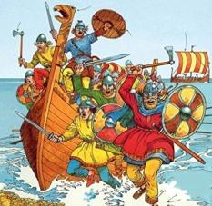 |  | Let There Be Light  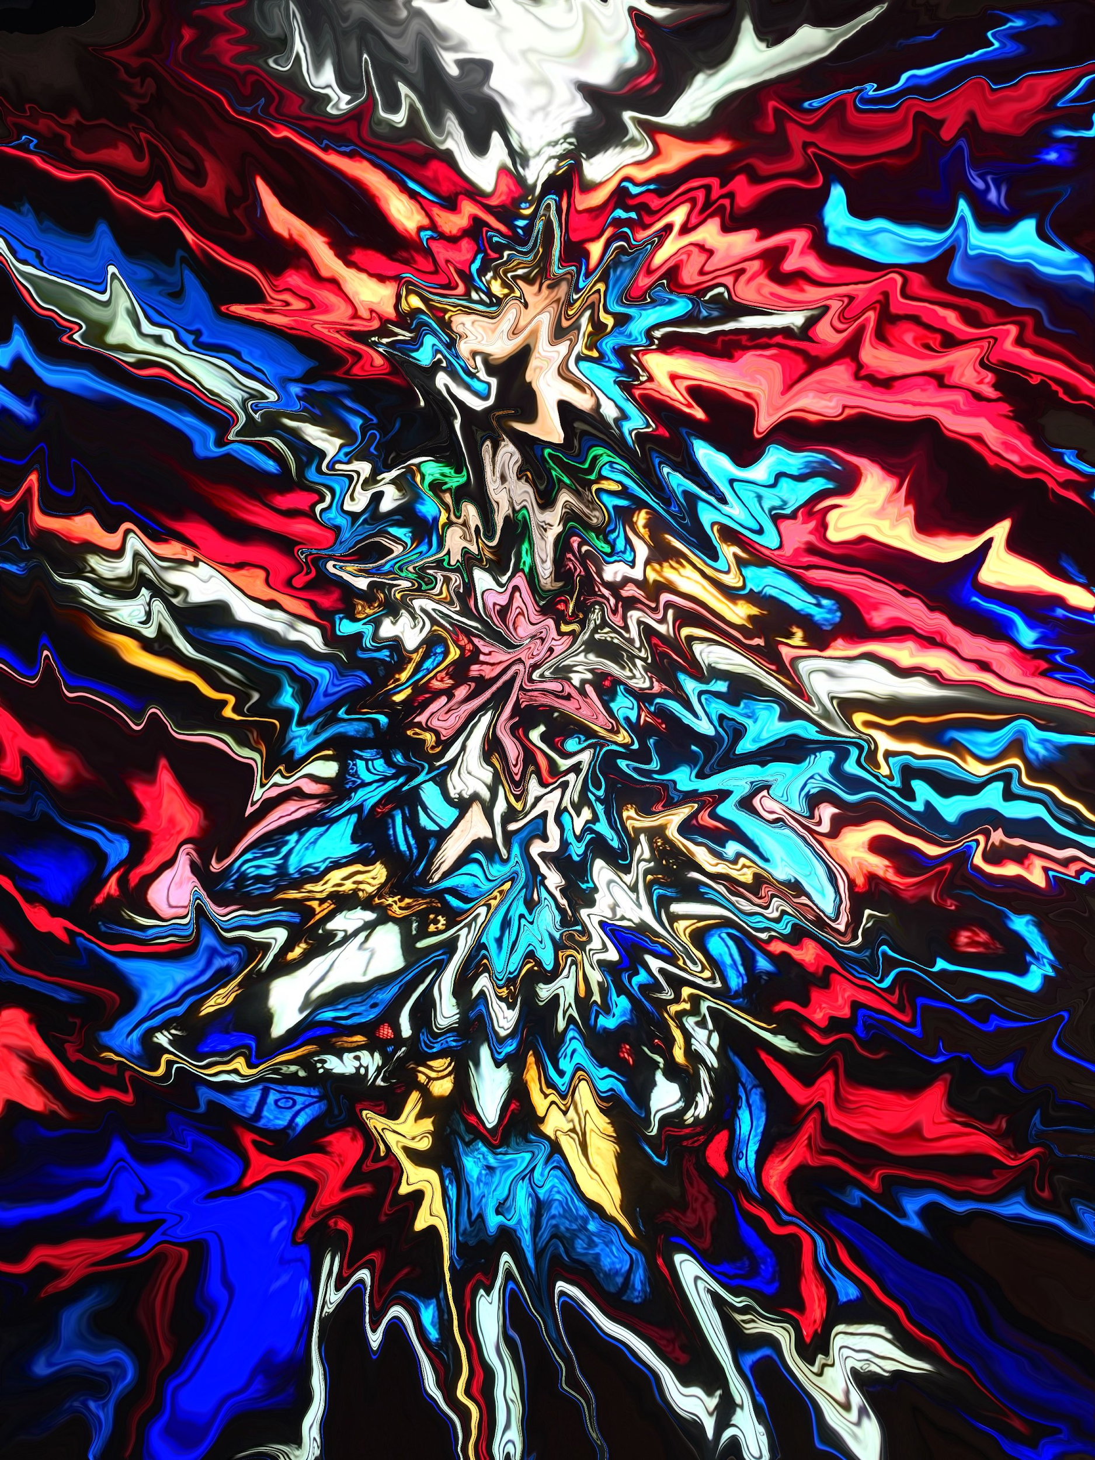 |  | Exploring the Alps  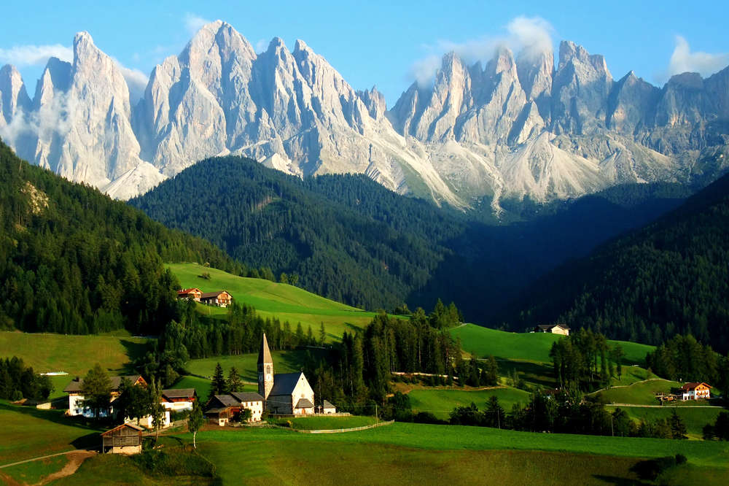 |  | Witney – Place in Time  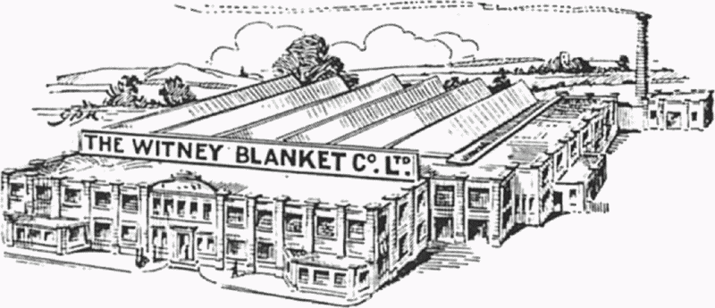 |  | Coasts  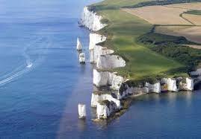
Subject Focus  History: Were the Vikings really vicious? Anglo-Saxons & Vikings – struggle for power; trade in Viking times. |  | Subject Focus  RE: Incarnation; symbolism of light in different religions. |  | Subject Focus  Geography: Region of Europe: weather including seasonal change and how this relates to location; mountains in UK and Europe (compare and contrast); tourism. |  | Subject Focus  History: Local study; link to theme of trade (textiles).  Geography: Local study with fieldwork (textile trade). |  | Subject Focus  Geography: Coastal features and processes; coastal settlements; fieldwork.
Linked Learning  Geography: Mapping UK and Europe; coasts vocab.  Computing: Scratch animations of Vikings doing different activities.  DT: Viking long ships (joining wood to make strong framework; finishing techniques; evaluation). |  | Linked Learning  Science: Light  Art and Design: Create stained glass windows (different techniques; link to artist study – who?)  Computing: Use graphics software to design patterns from tessellated and rotated shapes. |  | Linked Learning  Science: States of matter; electricity.  DT: Design and make ski lifts.  Art and Design: Use of space and perspective in landscapes.  MFL: Greetings in Alpine languages; possibly weather unit in French. (no longer possible with switch to Spanish)  Computing: Create and interrogate databases of mountains and settlements in the Alps and other mountain ranges; create interactive web page maps of key locations in the Alps. |  | Linked Learning  DT: Design and create class blanket, knitting squares.  Art and Design: Use of perspective in pictures of buildings.  Computing: Use spreadsheet software to explore and present key data from our enquiries. |  | Linked Learning  History: Trade by sea.  Science: Classification, food chains, changing habitats.  Computing: Stop motion animations of erosion.  Art and Design: Set design for performance of Treasure Island.  DT: Create props for performance of Treasure Island.
Text(s)  Odd and the Frost Giants by Neal Gaiman. |  | Text(s)  Skellig by David Almond. |  | Text(s)  Great Adventurers by Alastair Humphreys.  A Series of Unfortunate Events by Lemony Snicket. |  | Text(s) |  | Text(s)  Oliver and the Seawigs by Philip Reeve and Sarah McIntyre.  Fog by Carl Sandburg.  Flotsam by David Weisner.  Treasure Island by Robert Louis Stevenson.
Hook  Wow day: Viking Raid |  | Hook  Science Oxford show about Light. |  | Hook |  | Hook  Witney trip - geography fieldwork and local business. |  | Hook  Use Flotsam as hook – wow day.
Celebration  Museum for parents – educating them on different interpretations of Vikings. |  | Celebration  KS2 carol concert; hall display; gifts for family based around our theme. |  | Celebration  ‘Exploring the Alps’ website. |  | Celebration  Class assembly Y4/5 (focus: Witney). |  | Celebration  Class assembly Y5/6 (focus: trade).  Performance – Treasure Island. (Starshine Music.)
Trips  Treasure Hunters at Ashmolean Museum. |  | Trips |  | Trips |  | Trips  Witney trip - geog fieldwork and Woollen Weavers? |  | Trips  Coast trip - fieldwork. (Ideally Swanage)
Extra! Extra!  Art and Design: Design and make a Viking shield. |  |  |  | Extra! Extra!  Computing: Controlling the ski lift. |  |  |  | Extra! Extra!  Computing: Create and publish ‘Treasure Island’ games.
Maths and English  English: Viking raid narratives (atmosphere / setting); NC reports on Viking long ships (going into T2).  Maths: White Rose scheme. |  | Maths and English  English: Narratives linked to Christmas; focus on dialogue?  Maths: Geometry (2D shape: create tessellated and rotated patterns for stained glass windows) - as a short unit before Christmas instead of White |  | Maths and English  English (T3): Plot in adventure narratives. (Could link e.g. lost in the Alps…) Comics for Y2 to tell the tale of their chosen adventurer.  English (T4): Adverts and flyers (Alps tourism).  Maths: Measurement and comparison; statistics e.g. graphs of weather / tourist numbers across the year etc. (e.g. as one lesson a week or within topic lessons?)  Maths: White Rose scheme. |  | Maths and English  English: Instructions (written and recorded).  Maths: White Rose scheme. |  | Maths and English  English: Explanations; poetry (what type?); something linked to Oliver and the Seawigs.  Maths: White Rose scheme.
Other Learning  Science: Animals including humans - digestive system, teeth.  RE: Creation (what do Christians learn from the Creation story?)  PE: Running, Football, Gymnastics (Symmetry and Asymmetry)  PSHE: (4) What strengths, skills and interests do we have?  (5) What makes up a person’s identity?  MFL: Spanish – Classroom language, telling time, likes and dislikes, what you would like to eat. |  | Other Learning  Science: TBC  RE: Incarnation (What is Trinity?)  PE: Gymnastics (Bridges), Dance (Cats)  PSHE: (4) How can we manage our feelings?  (5) How can drugs common to everyday life affect health?  MFL: Spanish – what you would like to eat, wat others eat, dictionary work, expressions of frequency. |  | Other Learning  Science: TBC  RE: Hinduism  PE: Invasion (Hockey and Netball)  PSHE: (4) How can our choices affect others?  (5) What jobs would we like?  MFL: Spanish – applying phonics knowledge, opinions about sports, present tense, what sports you do. |  | Other Learning  Science: TBC  RE: Why do Christians call the day Jesus died ‘Good Friday’?  PE: Striking & Fielding (Cricket), Maypole Dancing  PSHE: (4) How will we grow and change?  (5) What decisions can people make with money?  MFL: Spanish – pronouns, verb endings, actions of others, giving instructions. |  | Other Learning  Science: TBC  RE: Hinduism  PE: Striking & Fielding (Rounders), Athletics Competitions  PSHE: (4) How do we treat each other with respect? How can we manage risk in different places?  (5) How can friends communicate safely? How can we help in an accident or emergency?  MFL: Spanish – types of music and likes/dislikes, listen and understand Spanish version of English song, learning adjectives, giving reasons.

