Autumn 1 | Autumn 2 |  | Spring 1 |  | Spring 2 | Summer 1 |  | Summer 2
When was the best time to be alive – Stone Age, Bronze Age or Iron Age? 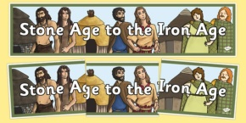 |  | Do we have extreme weather in the UK?  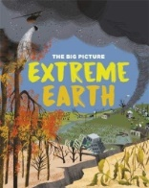 | What does it take to be a ‘Wonder?’  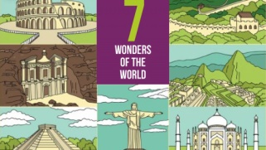 | Were the Ancient Egyptians like us?  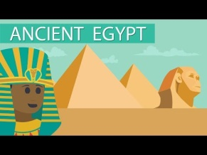 |  |  | Can we still see the Maya in Mexico?  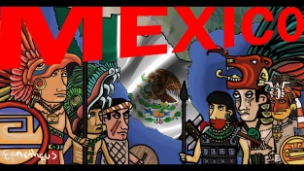
Subject Focus  History: How do we know about Britain’s Pre-History? From hunter gatherers to farmers; religion and ritual / Skara Brae. (HT) |  | Subject Focus  Geography: Mapping countries within continents / mapping cities with countries. / understanding and describing aspects of physical geography / Why don’t we have volcanoes in the UK?/ Position and significance of the equator. | Subject Focus  Geography: Mapping countries within continents / mapping cities with countries. /  Christ the Redeemer | Subject Focus  History: What did the Ancient Egyptians believe about life after death and how do we know? What does the evidence tells us about everyday life for men, women and children? Develop a chronologically secure knowledge and understanding of world history / devise historically valid questions about change, cause, similarity and difference, and significance / Construct informed responses that involve thoughtful selection and organisation of relevant historical information / Understand how our knowledge of the past is constructed from a range of sources / Note connections, contrasts and trends over time and develop the appropriate use of historical terms/ Construct informed responses that involve thoughtful selection and organisation of relevant historical information |  |  | Subject Focus  History Why do we study the Maya in history at KS2? Reasons why the Maya empire grew / Everyday life / Human sacrifice / The decline (Key stage History)  Geography: Use maps to locate North America, identifying some of its environmental regions, key physical and human characteristics, countries and major cities / Understand geographical similarities and differences through the study of human and physical geography in Mexico / Describe and understand key aspects of human and physical geography. Use maps to identify environmental regions, key physical and human characteristics, countries and major cities within Mexico.(HT)
Linked Learning  Geography: Identify symbols on a map around Avebury/Stonehenge. Identify specific grid references |  | Linked Learning  Science: Rock types.. | Linked Learning  RE: Catholicism .  ART: clay statues | Linked Learning  . |  |  | Linked Learning  Science – Light (Shadows)
Text(s)  Grandad’s Secret Giant  WRITING TO ENTERTAIN  (Narratives – Adventure story)  Convincing HT/Y6 that giants are good.  Stone Age Boy  (Narrative – Adventure story)  (reason?)  Using speech.  CLASS STORY  Stig of the Dump |  | Text(s)  Hurricane – David Weisner  Rain! – Sam Usher  WRITING TO INFORM  Postcards - Recount  Warning book (volcanoes / tsunamis / earthquakes) / Biography (Mary Anning)  CLASS STORY  How the Weather Works | Text(s)  Stone Henge Brochures  WRITING TO PERSUADE  .Tourist Advert – Stone Henge.  Letter writing – Responding to a letter suggesting that StoneHenge isn’t really a Wonder!  Possible recount?  (Seven Wonders Texts)  CLASS STORY  The Day the Crayon’s Quit | Text(s)  Texts from Ashmolean  The Day of Ahmed’s Secret  WRITING TO INFORM  Explanation text (mummies, jewellery, canopic jars)  (Find an instruction text )  Instruction texts (how to make a mummy)  The Day of Ahmed’s Secret  Describing settings (Egyptian scenes)  CLASS STORY  The Egyptian Cinderella – Shirley Climo?  Marcy and the Riddle of the Sphinx – Joe Todd Stanton. |  |  | Text(s)  Great Women who Changed the World  Children’s Mexico Cook Book  WRITING TO INFORM / ENTERTAIN  .Fridha Cahlo  Non-Chron Report  Stories from Other Cultures  Aluxes / Maya Adventure  Recipes  CLASS STORY  TBC
Trips  Stone Henge |  | Trips | Trips | Trips  Ashmolean |  |  | Trips  Mexicolore - Visitor
Hook  Trip to Stone Henge |  | Hook  Make a volcano. | Hook | Hook  Trip to Ashmolean |  |  | Hook  Mexicolore - Visitor
Celebration  Sharing books with Y6/HT |  | Celebration  KS2 carol concert; hall display; gifts for family based around our theme. | Celebration  ‘ | Celebration  Museum for parents – informing them on different Egyptian exhibits. |  |  | Celebration  Mexico Celebration – Pinata / Food
Maths and English  English: Narratives  Maths: White Rose scheme. |  | Maths and English  English: Post cards, warning book, biography.  Maths: White Rose scheme | Maths and English  English: Tourist advert, letter writing, recount.  Maths: White Rose scheme. | Maths and English  English: Explanation, instruction, describing a scene  Maths: White Rose scheme. |  |  | Maths and English  English: Npn chron report, Stories from other cultures, instructions.  Maths: White Rose scheme.
Other Learning  Science: Forces and Magnets  Geography:  RE: Would celebrating Divali at  home and in the community  bring a feeling of belonging  to a Hindu child?  Does participating in worship  help people to feel closer to  God or their faith community?  (Hinduism)  PE: Running, Football, Gymnastics  Computing: Esafety  MFL: RH Autumn  ART:TBC  DT:  PSHCE: What makes a good friend? |  | Other Learning  Science: Rocks  History: Remembrance.  RE: Incarnation  (What is the Trinity?)  PE: Gymnastics, Dance  Computing: Technology in our lives.  MFL: RH Autumn  ART:  DT: Volcano  PSHCE: What is bullying? | Other Learning  Science: Scientists & Inventors  History:  RE: Creation (what do Christians learn from the Creation story?  PE: Attack v defence, hockey, netball, ball skills  Computing: Programming  MFL: RH Spring  ART: Clay models  DT:  PSHCE: What helps us grow and stay healthy? | Other Learning  Science: Plants  Geography:  RE: Why do Christians call the day Jesus died ‘Good Friday’?  Would visiting the River Ganges feel special to a non-Hindu?  PE: Tag rugby, dance, cricket  Computing: Handling Data  MFL: RH Spring/Summer  ART:  DT:  PSHCE: What jobs do people do? What helps us to stay safe? |  |  | Other Learning  Science: Light  RE: Do religious people live better  lives?  Is religion the most important  influence and inspiration in  everyone’s life?  Does going to the Mosque give Muslims a sense of belonging? (Islam, Christianity).(Y2)  Trip to Mosque (Swindon)  PE: Maypole, jumping, Sports Day  Computing: Multimedia  MFL: RH Summer  ART: Air dry ‘Alibrijes’  DT: Mexican food  PSHCE: What helps us to stay safe? (cont)  How do we recognise our feelings?

