Autumn 1 | Autumn 2 | Spring 1 |  | Spring 2 | Summer 1 | Summer 2
Changes  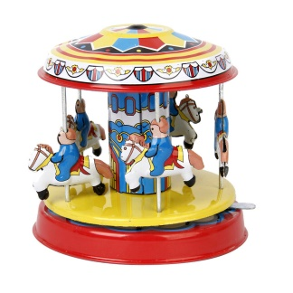 | Special Celebrations  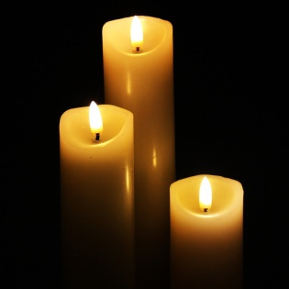 | Awesome Australia: What makes this country unique?  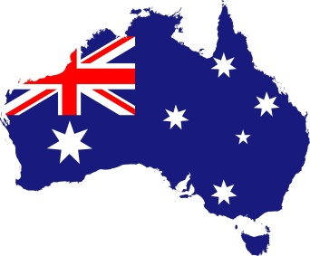 | Turrets and Tiaras: Why were castles built?  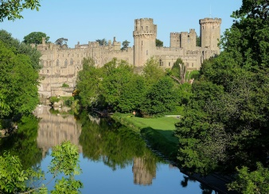 |  | Journeys: Where can we go?  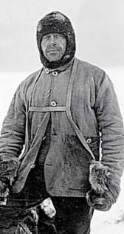 | Sand and salt: How have seaside holidays changed?  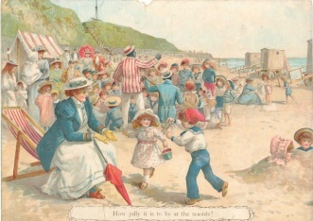
Main Focus  History: How have toys changed over time? (Changes within living memory). | Main Focus  History: Remembrance and Victorian Christmas mini topics (Significant national events).  RE Y1/2: Incarnation (Why does Christmas matter to Christians?). | Main Focus  Geography: Study of a non-European country (Compare Langford vs ----). Local study with fieldwork in Langford. | Main Focus  History: Why were castles built? (Changes beyond living memory).  Geography: Map work, placing castles in locations, fieldwork at Warwick Castle. |  | Main Focus  Geography: Equator, hot and cold places, seven continents and five oceans.  History: Scott of the Antarctic (Significant individual). | Main Focus  History: How have seaside holidays changed? (Changes beyond living memory).
Linked Learning  Y1 Science: Weather / seasonal changes + Working Scientifically.  Y2 Science: Working Scientifically linked to seasonal change.  RE Y1/2: Creation (Who made the world?)  English: On Sudden Hill / Bog Baby – changes in friendships and emotions (linked to PSHE).  PSHE: Y1 – What is the same / different about us?  Y2 – What makes a good friend? | Linked Learning  . | Linked Learning  Y1 Science: Animals including humans (categorising animals, herbivores etc, body parts) + Working Scientifically.  Y2 Science: Animals including humans (offspring and survival needs)  Art & Design: Develop a wide range of art and design techniques in using colour, pattern, texture, line, shape, form and space (textures / patterns – Aborginal Art). | Linked Learning  Y1 Science: Materials (identify and categorise materials) + Working Scientifically.  Y2 Science: Materials (testing, compare properties etc of materials) + Working Scientifically. |  | Linked Learning  Y1 Science: Animals including humans + Working Scientifically.  Y2 Science: Animals including humans (food chains and habitats) + Working Scientifically. | Linked Learning
Changes | Special Celebrations | Awesome Australia: What makes this country unique? | Turrets and Tiaras: Why were castles built? |  | Journeys: Where can we go? | Sand and salt: How have seaside holidays changed?
Text(s)  Here We Are  On Sudden Hill  Bog Baby | Text(s)  Leaf  Cat in the Manger  Twas The Night Before Christmas | Text(s)  Koala Lou  Wombat Goes Walkabout | Text(s)  Traditional tales  George and the Dragon  The Paper Bag Princess |  | Text(s)  Handa’s Surprise  Don’t Spill The Milk  Lost and Found | Text(s).  Storm Whale  The Secret of Black Rock
Trips | Trips  Church | Trips  Village walk - Langford | Trips  Warwick Castle  Church |  | Trips  Longleat Zoo | Trips  Mosque (Swindon)
Hook | Hook | Hook  Crocodiles of the World visit | Hook |  | Hook | Hook
Celebration  Chn designed Toy Museum | Celebration  Nativity performance (potentially filmed rather than live audience). | Celebration  Australia Day  . | Celebration |  | Celebration | Celebration  Picnic on the field with parents
Changes | Special Celebrations | Awesome Australia: What makes this country unique? | Turrets and Tiaras: Why were castles built? |  | Journeys: Where can we go? | Sand and salt: How have seaside holidays changed?
Extra! Extra! | Extra! Extra! | Extra! Extra! | Extra! Extra! |  | Extra! Extra! | Extra! Extra!
Maths and English  English:  Captions  Messages  Notices  Instructions  Maths:  Y1 – Place Value to 20  Addition and Subtraction  Y2 – Place Value to 100  Addition and Subtraction  2D shapes in CP | Maths and English  English:  Y1 - Speech bubbles, captions, comics.  Y2 – Different character perspective stories, descriptive writing.  Drama / performance  Maths:  Y1 – Place Value to 50 including money  Multiplication  Y2 – Place Value to 100 including money  Multiplication  2D shapes in CP | Maths and English  English:  Y1 – Fact file on Australian animals.  Y2 – Non Chron on Australian animals  Letters (write to Croc man to say thank you and explain learning)  Maths:  Y1 – Division  Place Value to 100  Length and Height  Y2 – Division  Statistics  Length and Height  3D shapes in CP | Maths and English  English:  Warnings / Wanted posters  Y1 - Retelling traditional tales (beginning, middle, end).  Y2 – Innovated stories (the true story!)  Recount (Castle trip)  Maths:  Y1 and Y2  –Fractions and consolidation  3D shapes in CP |  | Maths and English  English:  Lists for what to pack (hook)  Instructions – how to cheer up a penguin  Y1 - Recount of journeys  Y2 – Design own journey  Maths:  Y1 and Y2  Position and direction  Time  Problem Solving | Maths and English  English:  Y1 – Postcards  Y2 – Letters  Letters to coastal schools, letters in role as character describing events, persuading people to change minds etc.  Seaside poetry  (Celebration) Invitations for picnic on field.  Maths:  Y1 and Y2  Weight and Capacity  Temperature and Volume  Investigations and Consolidation
Other Learning  PE: Running / ball skills  ICT: eSafety, exploring school website, using Paint, programming Beebots  Art & Design: Use drawing, painting and sculpture to develop and share their ideas, experiences and imagination (linked to Recovery Curriculum).  Design Technology: Fabric faces. | Other Learning  Y1 Science: Animals including humans (the senses and basic body parts) + Working Scientifically.  Y2 Science: Animals including humans (exercise, food and hygiene) + Working Scientifically.  PE: Gymnastics / Dance  ICT: eSafety, exploring school website, using Paint, programming Beebots, taking photos and videos  Art & Design: Develop a wide range of art and design techniques in using colour, pattern, texture, line, shape, form and space (colour mixing, Vincent Van Gough – Starry Night).  Design Technology: Design, make and evaluate pop up Christmas cards.  PSHE: Y1 – Who is special to us?  Y2 – What is bullying? | Other Learning  RE Y1/2: Is Shabbat important to Jewish children? (Judaism, Christianity).  PE: Ball skills, hockey, netball  ICT: Data and research  Design Technology: Design, make and evaluate a fruit salad.  PSHE: Y1 – What helps us stay healthy?  Y2 – What makes us stay healthy and grow? | Other Learning  RE Y1/2: Salvation (Why does Easter matter to Christians?).  PE: Tag rugby / dance  ICT: Making word banks  Art & Design: Develop a wide range of art and design techniques in using colour, pattern, texture, line, shape, form and space (shape and colour - Castle and the Sun – Paul Klee – sketching castles).  Design Technology: Design, make and evaluate a castle structure.  PSHE: Y1 – What can we do with money?  Y2 – What jobs do people do? |  | Other Learning  RE Y1/2: Gospel (What is the good news that Jesus brings?)  PE: Jumping / Maypole  ICT: Data, making videos of journeys  Art & Design: Develop a wide range of art and design techniques in using colour, pattern, texture, line, shape, form and space (looking at warm and cool colours and hues / tones - Kandinsky).  Design Technology: Design a polar jacket by investigating materials.  PSHE: Y1 + Y2 – Who helps us to keep safe? | Other Learning  Y1 Science: Plants (common garden and wild plants, deciduous and evergreen trees) + Working Scientifically.  Y2 Science: Plants (seeds and bulbs, what plants need to grow) + Working Scientifically.  RE Y1/2: Does going to the Mosque give Muslims a sense of belonging? (Islam, Christianity).(Y2)  PE: Sports Day practise  ICT: Using internet to research journeys and the seaside  Art & Design: Use a range of materials creatively (natural sculptures incl Andy Goldsworthy).  Design Technology: Design, make and evaluate fabric bunting for our picnic. (sewing) + making a picnic to celebrate (food and hygiene).  PSHE: Y1 – How can we look after each other and the world?  Y2 – How do we recognise our feelings?

