Autumn 1 | Autumn 2 | Spring 1 |  | Spring 2 | Summer 1 | Summer 2
Changes  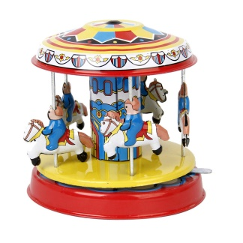 | Special Celebrations  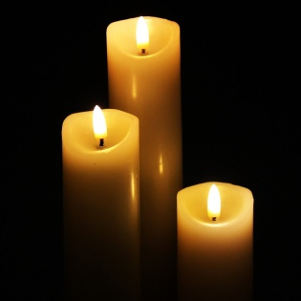 | Awesome Australia: What makes this country unique?  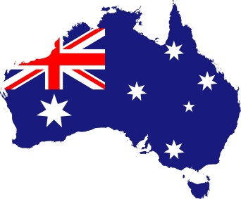 | Turrets and Tiaras: Why were castles built?  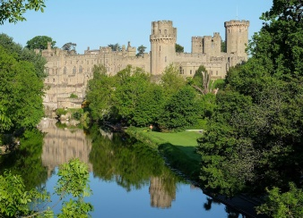 |  | Journeys: Where can we go?  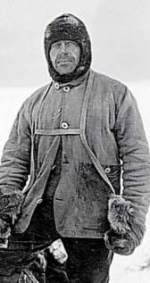 | Sand and salt: How have seaside holidays changed?  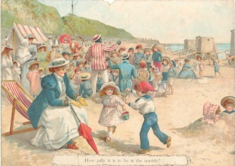
Main Focus  History: How have toys changed over time? (Changes within living memory). | Main Focus  History: Remembrance and Victorian Christmas mini topics (Significant national events).  RE EYFS UC : F2  Incarnation (Why do Christians perform Nativity plays at Christmas?)  RE Y1/2: Incarnation (Why does Christmas matter to Christians?). | Main Focus  Geography: Study of a non-European country (Compare Langford vs ----). Local study with fieldwork in Langford.  . | Main Focus  History: Why were castles built? (Changes beyond living memory).  Geography: Map work, placing castles in locations, fieldwork at Warwick Castle  . |  | Main Focus  Geography: Equator, hot and cold places, seven continents and five oceans.  History: Scott of the Antarctic (Significant individual). | Main Focus  History: How have seaside holidays changed? (Changes beyond living memory).
Linked Learning  EYFS UW World  Y1 Science: Weather / seasonal changes.  EYFS Science: Immediate environment  RE EYFS: What makes people special? (Christianity, Judaism) + Creation (Why is the word God so important to Christians?)  RE Y1/2: Creation (Who made the world?)  English: Here We Are  On Sudden Hill / Bog Baby – changes in friendships and emotions (linked to PSHE).  PSHE Y1: What is the same and different about us?  EYFS: As above plus continuous provision  Computing:  e-Safety, Programming  Technology in our lives  Art & Design: Use drawing, painting and sculpture to develop and share their ideas, experiences and imagination (linked to Recovery Curriculum).Design Technology: Fabric faces. | Linked Learning  .  PSHE Y1: Who is special to us?  EYFS: As above plus continuous provision  Computing:  e-Safety, Programming, Multimedia  Design Technology: Design, make and evaluate pop up Christmas cards. | Linked Learning  EYFS Science:  Immediate environment and how environments might vary from one another.  Observations of animals and plants  Y1 Science: Animals including humans (categorising animals, herbivores etc, body parts) + Working Scientifically.  Computing:  e-Safety, Programming,  Handling Data, Multimedia  Art & Design: Develop a wide range of art and design techniques in using colour, pattern, texture, line, shape, form and space (textures / patterns – Aborginal Art). | Linked Learning  Y1 Science: Materials (identify and categorise materials).  EYFS Science: materials  Computing:  e-Safety, Programming, Multimedia  Art & Design: Develop a wide range of art and design techniques in using colour, pattern, texture, line, shape, form and space (shape and colour - Castle and the Sun – Paul Klee – sketching castles).  Design Technology: Design, make and evaluate a castle structure. |  | Linked Learning  Y1 Science: Animals including humans (categorising animals, herbivores etc, body parts).  EYFS Science: animals  Computing:  e-Safety, Programming, Multimedia, Handling Data,  Art & Design: Develop a wide range of art and design techniques in using colour, pattern, texture, line, shape, form and space (looking at warm and cool colours and hues / tones - Kandinsky).  Design Technology: Design a polar jacket by investigating materials. | Linked Learning  EYFS Science:  Immediate environment and how environments might vary from one another.  Computing:  e-Safety, Programming, Technology in our lives  Design Technology: Design, make and evaluate fabric bunting for our picnic. (sewing) + making a picnic to celebrate (food and hygiene).
Changes | Special Celebrations | Awesome Australia: What makes this country unique? | Turrets and Tiaras: Why were castles built? |  | Journeys: Where can we go? | Sand and salt: How have seaside holidays changed?
Text(s)  Here we are  On Sudden Hill  Bog Baby | Text(s)  If you plant a seed  The Little Hen and The Great War  Cat in the Manger  T’was The Night Before Christmas | Text(s)  Koala Lou  Wombat Goes Walkabout | Text(s)  Traditional tales  George and the Dragon  The Paper Bag Princess |  | Text(s)  Handa’s Surprise  Don’t Spill The Milk  Lost and Found | Text(s).  Storm Whale  The Secret of Black Rock
Trips | Trips  Church | Trips  Village walk - Langford | Trips  Warwick Castle  Church |  | Trips  Longleat Zoo | Trips  Mosque (Swindon)  Pirate trip to Bristol
Hook  Toys Loan Box to investigate artefacts | Hook | Hook  Crocodiles of the World visit | Hook |  | Hook | Hook
Celebration | Celebration  Nativity performance | Celebration  Australia Day  . | Celebration |  | Celebration | Celebration  Picnic on the field with parents
Changes | Special Celebrations | Awesome Australia: What makes this country unique? | Turrets and Tiaras: Why were castles built? |  | Journeys: Where can we go? | Sand and salt: How have seaside holidays changed?
Extra! Extra! | Extra! Extra! | Extra! Extra! | Extra! Extra! |  | Extra! Extra! | Extra! Extra!
Maths and English  English: Captions, Messages, Notices, Instructions  Literacy EYFS: C&L, Reading and writing profile points  Maths: Y1 + EYFS Place Value  Number: Addition and subtraction | Maths and English  English: Y1 - Speech bubbles, captions, comics.  Literacy EYFS: C&L, Reading and writing profile points  Maths: Y1 + EYFS Patterns, Shape, Place Value, Consolidate | Maths and English  English: Y1 – Fact file on Australian animals.  Literacy EYFS: C&L, Reading and writing profile points  Maths: Y1 + EYFS Time, Addition and subtraction | Maths and English  English: Warnings / Wanted posters  Y1 - Retelling traditional tales (beginning, middle, end).  Literacy EYFS: C&L, Reading and writing profile points  Maths: Y1 + EYFS Place value, Measurement,  Consolidate |  | Maths and English  English: Lists for what to pack (hook)  Instructions – how to cheer up a penguin  Y1 - Recount of journeys fact files, letters, directions, adverts, innovated stories  Literacy EYFS: C&L, Reading and writing profile points  Maths: Y1 + EYFS Doubling and halving, Place value,  One less than, Position and Direction,  multiplication and division, Fractions | Maths and English  English: Y1 – Postcards  Literacy EYFS: C&L, Reading and writing profile points  Maths: Y1 + EYFS Money, Place Value, Weight, Volume,  Consolidate
Other Learning  PE: REC: Locomotion: Walking: Ball Skills Feet Gymnastics  Moving  Y1: Locomotion: Running:  Ball Skills Feet  Gymnastics: Wide, Narrow, Curled | Other Learning  Art & Design: Develop a wide range of art and design techniques in using colour, pattern, texture, line, shape, form and space (colour mixing, Vincent Van Gough – Starry Night).  PE:  REC: Gymnastics:  High, Low, Over, Under Dance  Ourselves  Y1: Gymnastics: Body Parts Dance: Growing | Other Learning  RE EYFS: Why do people celebrate? (Islam, Judaism).  RE Y1/2: Is Shabbat important to Jewish children? (Judaism, Christianity).  Design Technology: Design, make and evaluate a fruit salad.  PE:  REC: Attack Vs Defence  Games for understanding Ball Skills  Hands 1  Y1: Attack Vs Defence  Games for understanding Ball Skills:  Hands  PSHE Y1: What helps us stay healthy? EYFS: As above plus continuous provision | Other Learning  RE EYFS: Salvation (Why do Christians put a cross in the Easter  RE Y1/2: Salvation (Why does Easter matter to Christians?).  PE: REC:  Ball Skills Hands 2 Dance  Nursery Rhymes  Y1: Ball Skills Hands 2 Dance: The Zoo  PSHE Y1: What can we do with money?  EYFS: As above plus continuous provision |  | Other Learning  RE EYFS: What can we learn from stories? (Buddhism, Christianity, Islam, Hinduism, Sikhism).  RE Y1/2: Gospel (What is the good news that Jesus brings?)  PE:REC: Ball Skills Feet  Locomotion: Jumping  Y1: Dance TBC  Y1 Dance  Maypole  PSHE Y1: Who helps to keep us safe?  EYFS: As above plus continuous provision | Other Learning  RE EYFS: What makes places special? (Christianity, Islam, Judaism).  .  RE Y1/2: Does going to the Mosque give Muslims a sense of belonging? (Islam, Christianity).(Y2)  Art & Design: Use a range of materials creatively (natural sculptures incl Andy Goldsworthy).  PE: REC: Locomotion:  Jumping  Gymnastics  TBC  Y1: Locomotion:  Jumping  Athletics  Sports Day Practise  Y1 Science: Plants (common garden and wild plants, deciduous and evergreen trees).  EYFS Science: plants  PSHE Y1: How can we look after each other and the world?  EYFS: As above plus continuous provision

