Autumn 1 | Autumn 2 | Spring 1 |  | Spring 2 | Summer 1 | Summer 2
Comparing Britain, France and Mexico  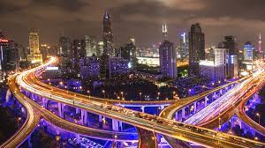 | Justice and Freedom  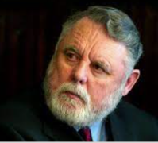 | images of Space  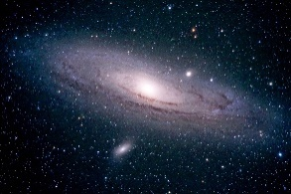 |  | Comparing People and Places (HT)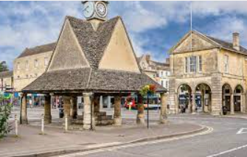 | Crime & Punishment (HT)  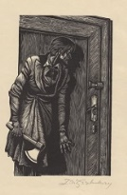 | The Maya & Chocolate (HT)  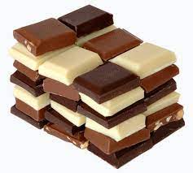
Subject Focus  Geography: What makes a country great? Physical and human features of countries around the world; how countries get natural resources.. | Subject Focus  RE: Incarnation; UC 2b.4 – Was Jesus the Messiah? | Subject Focus  Science: What Makes Planet Earth so Special? |  | Subject Focus  Geography: How are we connected to other places? Local study - map skills, human and physical features, rivers and other transport links. | Subject Focus  History: Was capital punishment the greatest deterrent? | Subject Focus  DT: Is milk chocolate the best chocolate when creating a chocolate bar?
Linked Learning  Science: Living things and their habitat (focus on British, French and Mexican plants and animals)  MFL: Spanish  Art and Design: Graffiti art. | Linked Learning  History: Those who faced injustice and lack of freedom in the past: Terry Waite; Nelson Mandela; Suffragettes  PSHCE: Communities we are part of; future projects for all mankind.  Computing: Handling Data –storing, searching and communicating data about astronauts.  Science: Sound | Linked Learning  Art and Design: Capturing the image and mood of planets and moons – matching media to the subject. (Charcoal, pastels, oil paints, digital art.)  Computing: Programming – animation or game set on another planet. Multimedia – digital art to create background of the game.  DT: Eggnaut (HT) |  | Linked Learning  History: How was our area connected to other places in the past? Local study – past settlements in the area through time; Witney Woollen Weavers; historic connections for trade.  Art and Design:. Mapping the Grand Canyon through art.  Computing: Technology in our lives. How are we connected through technology?  Science: Light  DT: A Mexican Fiesta: Costume & Decoration (HT)  MFL: Spanish | Linked Learning  PSHCE: Equality and diversity.  Science: Forces  DT: A fake head to escape from Alcatraz  Art and Design: Mug shots | Linked Learning  Geography: Where does chocolate come from? Chocolate trade links.  PSHCE: Fair Trade.  Computing: Multimedia – create website for our new product.  Science: Changes in materials/ States of matter.  MFL: Spanish
Text(s)  The Pear Affair – Judith Eagle | Text(s)  Opal Plumstead – Jaqueline Wilson | Text(s)  Phoenix – S F Said  War of the Worlds – HG Wells  Hidden Figures: The True Story of Four Black Women and the Space Race -  Simon Bartram  Dr Maggie's Grand Tour of the Solar System -  Dr Maggie Aderin-Pocock  Cosmic -  Frank Cottrell Boyce and Steven Lenton |  | Text(s)  Hello World - Jonathan Litton & L'Atelier Cartographik  A World of Cities – James Brown  Hello World – Johnathon Litton | Text(s)  The Tulip Touch – Anne Fine  Holes –  Louis Sachar | Text(s)  The Hero Twins  The Chocolate Tree
Trips | Trips | Trips  Star-gazing  Planetarium |  | Trips  Witney trip - geography and history fieldwork. | Trips  Oxford Castle | Trips  Cadbury World
Maths and English  English:  A Monster Calls (Scary)  The Graveyard Book (Mystery)  Maths:  Place Value  Four Operations | Maths and English  English:  Zoo – Anthony Browne (Narrative)  Kick (Persuasion)  Maths:  Fractions | Maths and English  English:  Mars Transmission (Journal)  Planet profile (non chron report).  Maths:  Fractions/Ratio  Decimals & Percentages  Algebra | Maths and English  English:  Argument & Debate (Discussion HT)  Thornhill ((Ghost Story)  The Path (Mystery/ Poetry)  Maths:  Measures  Statistics |  | Maths and English  English:  Goldilocks (Newspaper report)  Postcard from Prison (Recount)  Maths:  Geometry | Maths and English  English:  How to make their chocolate bar (instructions)  Maths:  Consolidation & Investigations

