Autumn 1 | Autumn 2 | Spring 1 | Spring 2 | Summer 1 | Summer 2
Stone Age to Iron Age  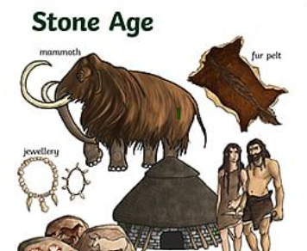 | Mountains  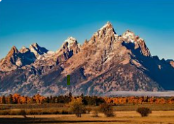 | Egyptians  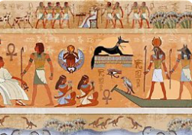 | Extreme Earth  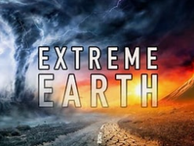 | Rainforests  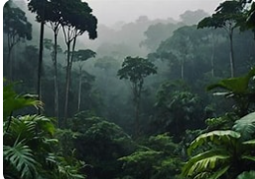 | Crime and Punishment  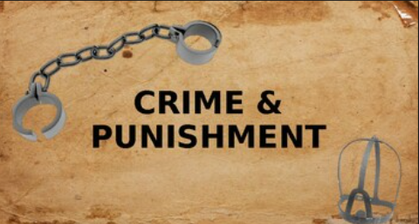
  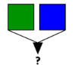  Skills Icons   | Skills Icons | 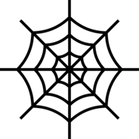  Skills Icons |   Skills Icons  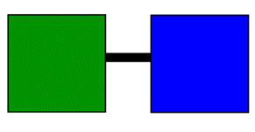   | Skills Icons | Skills Icons
Subject Focus  History  EQ: Was Stone Age man just a simple hunter gatherer? | Subject Focus  Geography  EQ: Where can we find mountains in the UK? | Subject Focus  History  EQ: How can we discover what life was like in Egypt 5000 years ago? | Subject Focus  Geography  EQ: How powerful is our Earth? | Subject Focus  History  EQ: How have punishments changed over the last 1000 years? | Subject Focus  Geography  EQ: Where are the world’s rainforests?
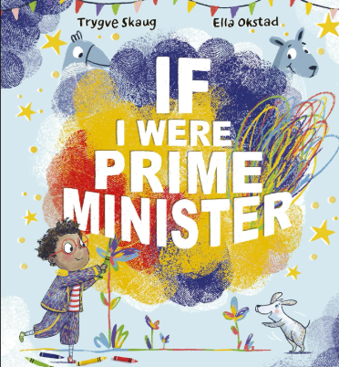 | Poetry | 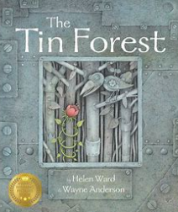 | 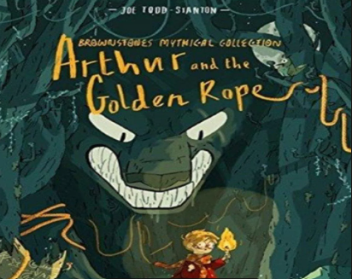 | 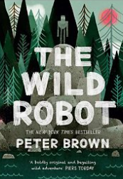 | 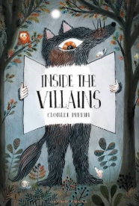
Trips  Stone Age Workshop | Trips  Panto | Trips | Trips | Trips | Trips
Maths  See White Rose Maths |  | Maths  See White Rose Maths |  | Maths  See White Rose Maths
English  Autumn 1: If I were Prime Minister Focus on foundational skills and short outcomes to practice transcriptional skills.  Potential outcomes:  - Manifesto  - Speech (spoken)  - Persuasive sentences | English  Poetry | English  Writing Outcome 1:  A wishing story  Writing Outcome 2:  Information text/persuasive leaflet about the Tin Forest. Encouraging people to come and visit.  Writing Outcome 3:  Setting description - creatures. | English  Writing Outcome 1: Non Chronological Report based on creatures from Arthur’s Golden Rope  Writing Outcome 2: Persuasive writing: should Arthur go on the quest? Townsfolk write to Arthur expressing their viewpoint.  Writing Outcome 3:  A guide to the village: Tourist attraction. | English  Writing Outcome 1:  Story opening - being in the middle of stormy/extreme weather.  Writing Outcome 2:  Create a book of emotions. Use ‘The Emotionary’ to support.  Writing Outcome 3:  Mini adventure - Roz on the Island. | English
Other Learning  Science: Are all rocks the same?  RE: Could Jesus heal people? Did he perform miracles or is there another explanation?  PE: Forest School + football  Computing: Computing Systems and Networks-IT around us.  ART: Storytelling Through Drawing  PSHCE: Being Me In my World  Spanish: I am Learning | Other Learning  Science: How do skeletons help humans and other animals?  RE: Has Christmas lost its true meaning?  PE: Hockey  Computing: Computing Systems and Networks-IT around us.  DT: Structures / Cooking and Nutrition  PSHCE: Celebrating Differences  Spanish: Animals | Other Learning  Science: How does light help us to see and create shadows?  RE: Who is God to Muslims?  PE: Multi skills  Computing: Computing Systems and Networks-IT around us.  ART: Cloth, Thread and Paint  PSHCE: Dreams and Goals  Spanish: Fruits | Other Learning  Science: How are fossils formed and what is soil made from?  RE: What is good bout Good Friday?  PE: Tennis  Computing:Computing Systems and Networks-IT around us.  DT: Textiles  PSHCE: Healthy Me  Spanish: In the Classroom | Other Learning  Science: How do forces affect the way an object moves?  RE: How important is the prophet Muhammad to Muslims?  PE: Quad Kids  Computing: Computing Systems and Networks-IT around us.  ART: Sculpture  PSHCE: Relationships  Spanish: Family | Other Learning  Science: How do different parts of a plant help it survive and grow?  RE: Why do Sanatannis use symbols?  PE: Cricket  Computing: Computing Systems and Networks-IT around us.  DT: Mechanisms  PSHCE: Changing Me  Spanish: Do You Have a Pet?

