Autumn 1 | Autumn 2 | Spring 1 |  | Spring 2 | Summer 1 | Summer 2
History – The History of Flight  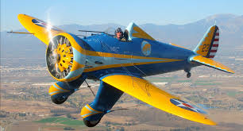 | Geography – Oxfordshire  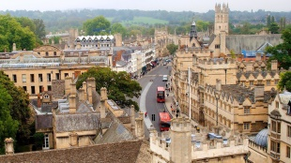 | History – Greeks  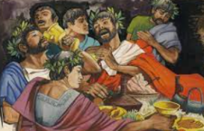 |  | Geography – Marvellous Maps  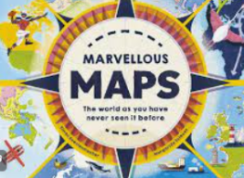 | History – Black British History  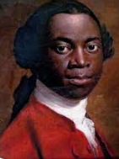 | Geography – Perplexing Poles  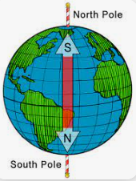
Subject Focus  History: How have aeroplanes helped to change the world? (Key Stage History) | Subject Focus  Geography: Local study – Oxfordshire (Key Stage History) | Subject Focus  History: What was it that made ancient Greece so great? (Kay Stage History) |  | Subject Focus  Geography: Geographical skills (HT)  Or  Marvellous Maps (Twinkl) | Subject Focus  History: Black and British (Key Stage History) | Subject Focus  Geography: TBC
ART: Storytelling Through Drawing (Access Art)  PSHCE: Being Me in my World  Science – Rocks (HT)  RE: UC2a.4 How are different people inspired by the teachings of Jesus?  Spanish: I am learning…  Computing: computing-systems-and-networks-the-internet (Y4)  PE:  GYM –Symmetry/Asymmetry  GAMES – Football skills  Music: Let Your Spirit Fly | DT: Digital World  PSHCE: Celebrating Difference  Science – Living things and their habitat (HT)  RE: UC2a.5– How does the worldwide Christian family celebrate, worship and mark key events?  Spanish: Colours & Numbers and Greetings (from KS1 section)  Computing: Creating media - Audio production (Y4)  PE:  GAMES – Hockey skills  HEALTH & FITNESS – Mindfulness  Music: Glockenspiel Stage 1 | ART: Cloth, Thread, Paint (Access Art)  PSHCE: Dreams & Goals  Science – Animals including humans  RE: UC2a.6 - Does art help with understanding stories?  Spanish: Musical Instruments  Computing: Programming A – Repetition in shapes (Y4)  PE:  Swimming  GAMES – Tag Rugby skills  Music: Three Little Birds |  | DT: Cooking & Nutrition  PSHCE: Healthy Me  Science – Light (HT)  RE:– What do Muslims believe about God and where did Islam start? (Twinkl Y3 Planit)  Spanish: Ancient Britain  Computing: Data and information – Data logging (Y4)  PE:  GAMES – Tennis skills  DANCE – Witches & Wizards  Music: The Dragon SOng | ART: Sculpture, Structure, Inventiveness & Determination (Access Art)  PSHCE: Relationships  Science – Plants (HT)  RE: - What is the Qur’an and why do many Muslims try to learn it by heart? (PlanBee)  Spanish: Fruits  Computing: Creating media – Photo editing (Y4)  PE:  GAMES – Netball Skills  GAMES - Cricket skills  Music: Bring Us Together | DT: Electrical Systems  PSHCE: Changing Me  Science – Electricity (HT)  RE: - Does it matter if a story is true or not? (TBC)  Spanish: Vegetables  Computing: Programming B – Repetition in games (Y4)  PE:  OUTDOOR ADVENTURE – Orienteering  GAMES - Athletics  Music: Reflect, Rewind, Replay
Text(s) | Text(s) | Text(s) |  | Text | Text | Text
Trips | Trips | Trips |  | Trips | Trips | Trips
Maths and English  English:  The Incredible Book Eating Boy  Autumn is Here  Maths:  Place Value  Multiplication & Division  Addition & Subtraction | Maths and English  English:  How a Robot Dog Works  The Princess and the Pea  Maths:  Fractions  Multiplication & Division  Addition & Subtraction  Shape | Maths and English  English:  Theseus and the Monitaur  Still I Rise  Maths:  Place Value  Fractions  Addition & Subtraction  Measure  Decimals & Money | Maths and English  English:  Still I Rise (cont)  My Strong Mind  Maths:  Decimals & Money  Multiplication  Addition & Subtraction  Division  Time |  | Maths and English  English:  The Wolves in the Wall  The Gardener  Maths:  Number & Place Value  Addition & Subtraction  Multiplication & Division  Decimals  Shaope | Maths and English  English:  The Gardener (cont)  Journal of Iliona  Maths:  Shape  Addition & Subtraction  Multiplication & Division  Fractions

