Autumn 1 | Autumn 2 | Spring 1 | Spring 2 | Summer 1 | Summer 2
The History of Flight  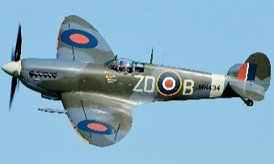 | Oxfordshire  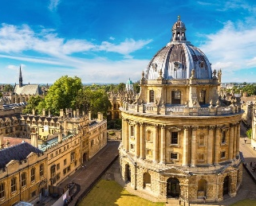 | 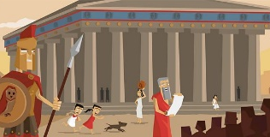  Ancient Greeks | 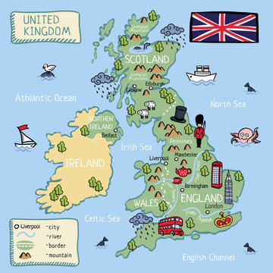  Marvellous Maps | 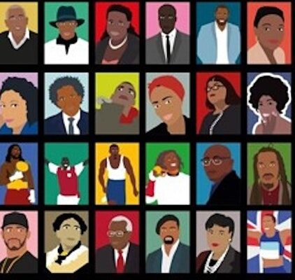  Black British History | 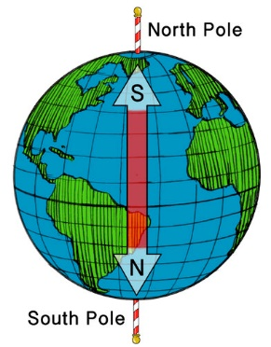  Perplexing Poles
Skills Icons  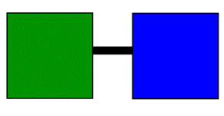 |       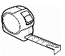  Skills Icons |   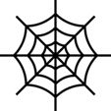  Skills Icons | Skills Icons    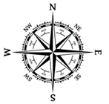 |   Skills Icons | 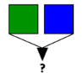  Skills Icons
Subject Focus  History: Local History study.  EQ: How has the science of aeroplanes changed over time?  HOOK: Trip to RIAT (Summer 22-23) | Subject Focus  Geography: Use fieldwork. Understand geographical similarities and differences of a region of the United Kingdom.  EQ: Why do people visit Witney? | Subject Focus  History: Ancient Greek influence on Western world.  EQ: Which was better, Athens or Sparta? | Subject Focus  Geography: Eight points of compass, four and six figure grid references, maps, atlases, globes, latitude/longitude, equator etc.  EQ: What is the purpose of a map? | Subject Focus  History: Extends knowledge beyond 1066 – theme – chronology/theme.  EQ: What difference did the Slave Trade have on the lives of black people? | Subject Focus  Geography: Arctic/Antarctic Circle. Climate zones. Types of settlement.  EQ: What would it be like to be an Antarctic explorer?  HOOK: Shackleton Investigation Day
Text(s)  The Iron Man | Text(s)  Odd and the Frost Giants (Whole Class Reading)  A Christmas Carol | Text(s)  Who let the Gods out? – Maz Evans  Theseus and the Minotaur | Text(s)  Arthur and the Golden Rope (Whole class reading)  The Accidental Prime Minister | Text(s)  Walter Tull’s Scrapbook (Whole class reading)  Windrush Child | Text(s)  Shackleton  Finding Bear
Trips | Trips  Panto  Fieldwork trip to Witney | Trips  Ashmolean Museum | Trips  Hill End Outdoor Centre | Trips | Trips  RIAT?
Maths  See White Rose Maths |  | Maths  See White Rose Maths |  | Maths  See White Rose Maths
English  Entertain  ‘The Piano’ Informal Letter  Entertain  Science Fiction Narrative – The Iron Man | English  Inform  Recount – Newspaper Article. Classroom event (thief?)  Entertain  Christmas Narrative (focus on Dialogue) – A Christmas Carol | English  Inform  Non-Chronological reports about Ancient Greeks (specific place/event etc.)  Entertain  Greek Myths – Theseus and the Minotaur | English  Entertain  The Highway Man by Alfred Noyes – Narrative Poem  Inform  Instruction writing | English  Discussion  Based on a debate linking to big question around Black History Month  e.g. Does society treat all people equally?  Entertain  Short stories | English  Entertain  Adventure Narrative (focus on Character) – Antarctic explorer?  Entertain  Stories including dialogue.
Other Learning  Science: Earth and Space  RE: Who do Christians believe Jesus is?  PE: Counterbalance & Counter Tension, Football  Computing: Connecting Computers  MFL: Home  ART: Exploring Still Life (Cezanne)  PSHCE: Ages 9-10 – Being Me in my World | Other Learning  Science: Forces  RE: How and why has Christian practice changed over time?  PE: Swimming, Hockey  Computing: Sequence in Music  DT: Electrical Systems  PSHCE: Ages 9-10 – Celebrating Difference | Other Learning  Science: Properties of Materials  RE: Does prayer make a difference and how do Christians know?  PE: Tag Rugby, Greeks  Computing: Branching Databases  MFL: Myself  ART: Making Monotypes (Kevork Mourad)  PSHCE: Ages 9-10 – Dreams and Goals | Other Learning  Science: Changes of Materials  RE: How do Hindus understand God (Brahman)?  PE: Tennis, Counterbalance & Counter Tension  Computing: Desktop Publishing  DT: Digital World  PSHCE: Ages 9-10 – Healthy Me | Other Learning  Science: Living things and Their Habitats  RE: What role does worship play in the life of a Hindu?  PE: Netball, Cricket  Computing: Events and Actions  MFL: Family  ART: Sketch for Survival Art Competition  PSHCE: Ages 9-10 – Relationships | Other Learning  Science: Animals Including Humans  RE: How and why do people argue that some places can be spiritual?  PE: Athletics, Orienteering  Computing: Stop Frame Animation  DT: Cooking and Nutrition  (DT Week: CAD Automata)  PSHCE: Ages 9-10 – Changing Me

