Summer Data 2026

 | 2023 |  | 2024 |  | 2025
KS2 SATs | School | National | School | National | School | National
Reading | 67% | 74% | 64% | 75% | 93% | 75%
Writing | 76% | 72% | 52% | 72% | 80% | 73%
Maths | 57% | 73% | 52% | 74% | 80% | 75%
Combined | 57% | 61% | 36% | 62% | 80% | 63%
Year 1 phonics | 88% | 80% | 82% | 80% | 88% | 82%
By end of Year 2 | 100% | 89% | 80% | 89% | 82% | 91%
GLD | 90% | 68% | 89% | 68% | 94% | 72%

Narrative:
Statutory outcomes for 2025 demonstrate a highly positive picture, with significant improvements across all key measures and attainment exceeding national averages in almost every area. Early Years continues to be a considerable strength, with 94% of children achieving a Good Level of Development, substantially above the national figure of 72%, reflecting consistently high-quality provision and strong foundations for future learning. Phonics outcomes have remained consistently strong over the three-year period, with 88% of pupils meeting the expected standard in the Year 1 Phonics Screening Check, above the national average of 82%, demonstrating the effectiveness of the school's systematic approach to early reading. Although the proportion of pupils meeting the standard by the end of Year 2 reduced to 82%, this reflects the specific needs of a small cohort and will remain an area for continued focus.
At Key Stage 2, outcomes have improved dramatically since 2024. Reading attainment increased from 64% to 93%, placing the school well above the national average of 75% and highlighting the impact of sustained investment in reading fluency, comprehension and vocabulary. Writing outcomes rose from 52% to 80%, while mathematics increased from 52% to 80%, both exceeding national outcomes and demonstrating improved consistency in teaching, curriculum implementation and assessment. Consequently, combined attainment rose from 36% in 2024 to 80% in 2025, significantly above the national average of 63%. This represents exceptional progress over a single academic year and reflects the effectiveness of targeted intervention, high-quality teaching and strong leadership across the school.
Overall, the school's statutory outcomes demonstrate that pupils achieve exceptionally well across the curriculum. Strengths are evident in Early Years, phonics and Key Stage 2 attainment, with particularly impressive gains in reading, writing and mathematics. Moving forward, leaders will continue to sustain these high standards while ensuring that pupils requiring additional support in phonics and early reading receive timely intervention, enabling the school to maintain consistently high outcomes for all learners.

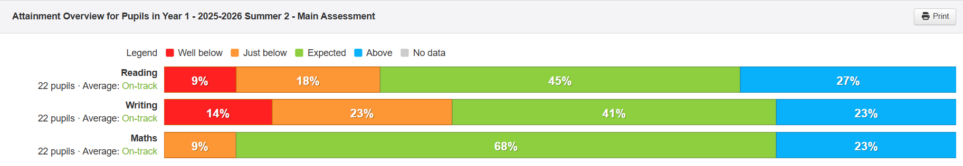

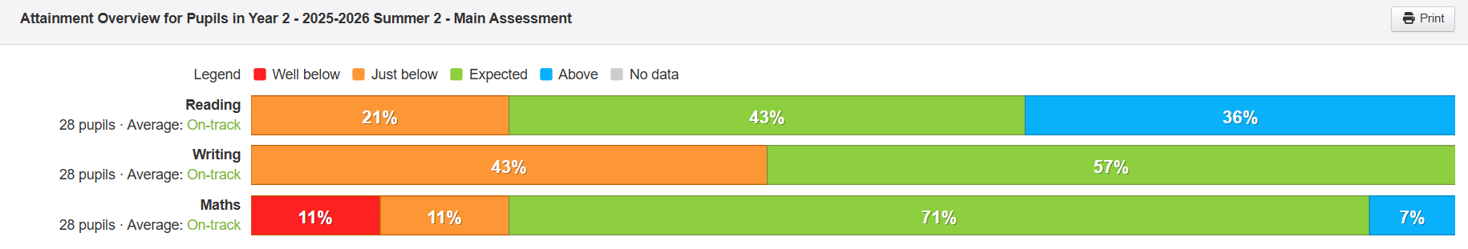

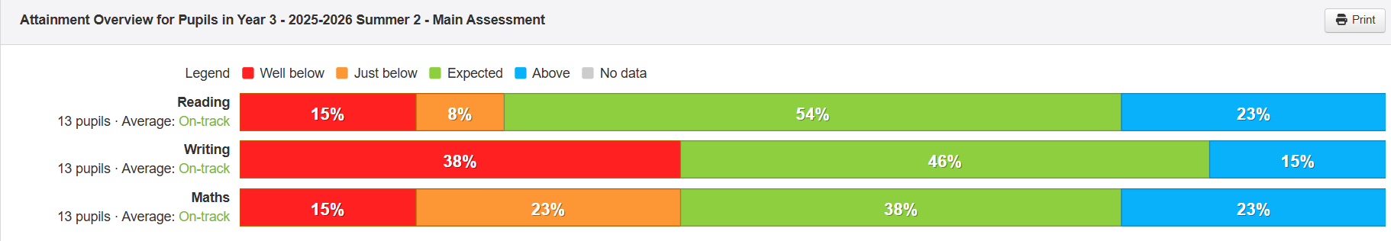

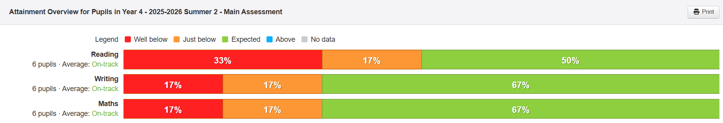

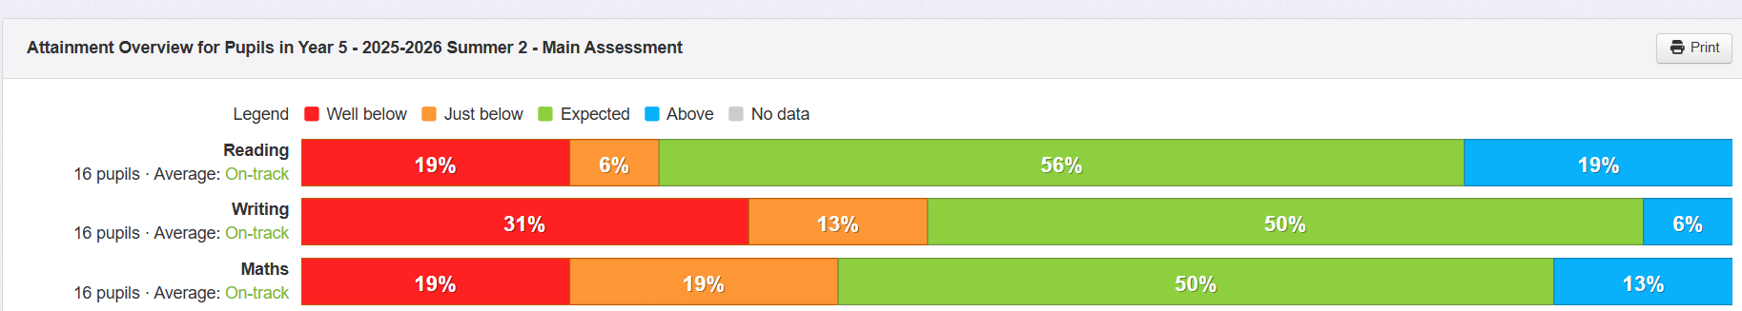

Narrative:

Year 1
Year 1 outcomes present a positive picture overall, with mathematics emerging as the strongest subject. 91% of pupils are working at or above the expected standard in mathematics, with almost a quarter achieving above the expected standard. Reading is also a strength, with 72% of pupils achieving expected or above, including 27% working at greater depth. Writing is comparatively weaker, with 64% of pupils working at or above the expected standard and over a third of pupils requiring further support. The focus moving into Year 2 should be on developing pupils' independent writing skills while maintaining strong outcomes in mathematics and reading.

Year 2
Year 2 demonstrates particularly strong attainment in mathematics, where 78% of pupils are working at or above the expected standard. Reading is also a strength, with 79% achieving expected or above, including a high proportion of pupils working above the expected standard. Writing, however, remains the main area for development, with 43% of pupils working just below the expected standard and no pupils currently achieving above expected. This suggests that many pupils are close to meeting age-related expectations and would benefit from targeted support to secure writing outcomes.

Year 3
Year 3 outcomes are more variable across the curriculum. Reading remains the strongest subject, with 77% of pupils achieving expected or above, demonstrating secure comprehension and fluency. Writing is more evenly balanced, with 61% working at or above the expected standard, although over a third of pupils remain below expectations. Mathematics presents the greatest challenge, with 38% of pupils working below the expected standard and 61% achieving expected or above. Continued focus on mathematical fluency, reasoning and problem solving will be important to strengthen attainment across the cohort.

Year 4
Year 4 outcomes indicate that the majority of pupils are working securely at the expected standard, although there are relatively few pupils achieving greater depth. Reading is the weakest of the three core subjects, with 50% of pupils achieving the expected standard, while half remain below expectations. Both writing and mathematics show 67% of pupils working at the expected standard, although no pupils are currently exceeding age-related expectations. Given the very small cohort size, individual pupils have a significant impact on percentages, but increasing the proportion of pupils working above the expected standard should be a priority alongside accelerating progress for those below.

Year 5
Year 5 presents a mixed attainment profile. Reading is the strongest subject, with 75% of pupils working at or above the expected standard, providing a solid foundation ahead of Year 6. Writing outcomes are weaker, with 56% achieving expected or above, and almost a third of pupils working well below expectations. Mathematics also requires continued development, with 63% of pupils achieving expected or above, while a substantial minority remain below the expected standard. Targeted intervention for pupils working just below age-related expectations should enable many to make accelerated progress before Key Stage 2 statutory assessments.

Overall narrative
Across Years 1–5, reading is the strongest curriculum area, with most year groups showing high proportions of pupils achieving the expected standard or above and several cohorts demonstrating strong greater depth attainment. Mathematics is strong in Key Stage 1 but becomes more variable in Key Stage 2, particularly in Years 3 and 5, where a larger proportion of pupils remain below age-related expectations. Writing is the least consistent subject across the school, with several cohorts containing pupils working just below the expected standard rather than significantly below. This indicates that targeted intervention, high-quality adaptive teaching and regular opportunities for extended writing should enable many pupils to achieve age-related expectations. Overall, the data suggests a secure foundation in reading, positive outcomes in Key Stage 1, and clear priorities for improving consistency in writing and mathematics across Key Stage 2.

