Spring Term – Term 3 - Maple Class
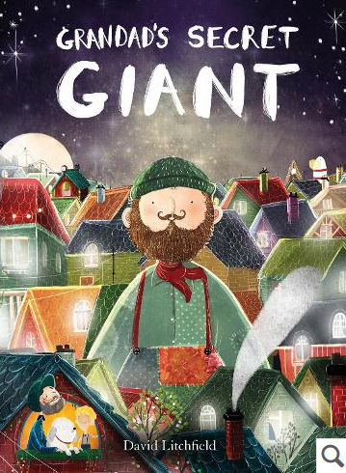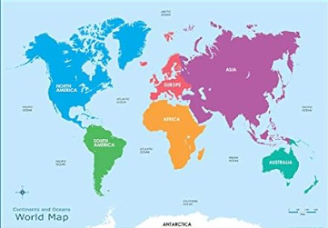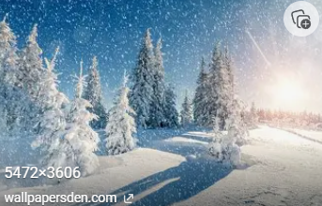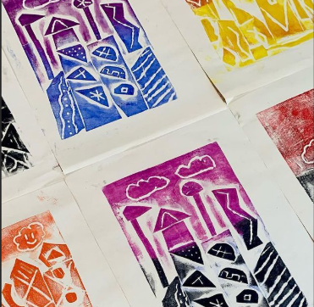
English – Our focused text for this term is ‘Grandad’s Secret Giant’. We will be including a number of experience days within our English lessons to inspire children with their writing. We will also be enjoying other books written by David Litchfield to expand on our knowledge.
Whole Class Reading: In our whole class reading sessions we will be enjoying books linked to our English focused texts as well fact books about Oceans and Continents.
Maths- This term we will be focusing on Place Value (within 20). The children will be exploring number through a wide range of provision-based activities as well as our whole class learning.
Science– During the term we will exploring Winter as a season. We will be taking on the role of ‘Winter Weather Watchers’. We will be recording data and making observations. We will use the season to inspire us with our Art – in particular, ice!
Geography - Our Geography focus this term is ’Journeys’, We will be locating and identifying oceans and continents, exploring British beaches and using fieldwork skills. . We will compare British beaches and use a compass to move around a map.
RE – In RE we are answering the question – Who is God to the Jews?
PSHCE – Our topic this term is ‘Dreams & Goals’. This will have a focus on what we can achieve when we work together, how we can overcome obstables and celebrating success.
PE – The children will be focusing on ‘Games for Understanding’. PE will take place on Mondays, please ensure your child’s PE kit is in school all week. We will also be visiting Forest School on a Wednesday, therefore your child will need long sleeved tops and bottoms as well as waterproofs for our outdoor learning.
Music – In music this term we will be focusing on ‘In the Groove’. The children will be singing, playing instruments and composing music.
Computing – In computing we will be having fun with ‘Moving a Robot’. We will be using our compass point knowledge as well as forwards, backwards, left and right to direct a Robot!

