Autumn Term – Term 2 - Maple Class
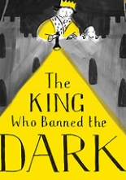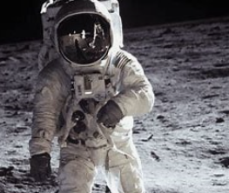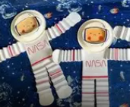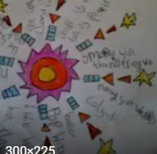
English – Our focused text for this term is ‘The King Who Banned The Dark’. We will be including a number of experience days within our English lessons to inspire children with their writing. Linked to this book we will also be exploring poetry with fireworks focus.
Whole Class Reading: In our whole class reading sessions we will be enjoying books linked to our English focused texts as well fact books about Space and Materials.
Maths- This term we will be focusing on addition, subtraction and geometry. The children will be exploring number through a wide range of provision-based activities as well as our whole class learning.
Science and DT – During the term we will exploring a variety of materials and their properties. We will be linking this to DT and exploring which materials would be best for an astronaut and use materials to make space puppets.
History- Our History focus this term is Space. We will learn about the Moon Landing as well as scientists today such as Maggie Aderlin-Pocock. We will explore how space travel has changed and advanced.
RE – In RE we are answering the question – What might Christians in my town have given to Jesus if he had been born here rather than Bethlehem?
PSHCE – Our topic this term is ‘Celebrating Difference’.
PE – The children will be focusing on ‘Dodging’. PE will take place on a Mondays, please ensure your child’s PE kit is in school all week. We will also be visiting Forest School on a Wednesday, therefore your child will need long sleeved tops and bottoms as well as waterproofs for our outdoor learning.
Music – In music this term we will be focusing on rhythm and rapping. The children will be working in small groups and performing to one another.
Computing – In computing we will be having fun with digital painting. We will be using the Paintz app and embedding and expanding upon our knowledge from last term.

