Autumn Term – Term 1 - Maple Class
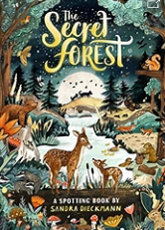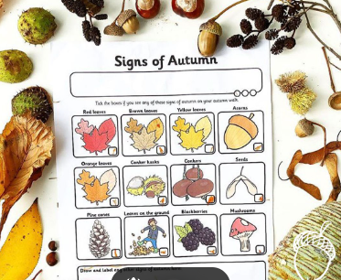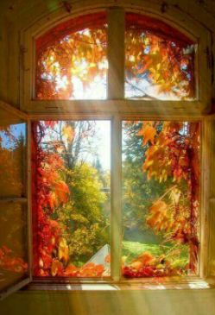
English – Our focused text for this term is ‘The Secret Forest’. We will be including a number of experience days within our English lessons to inspire children with their writing.
Whole Class Reading: In our whole class reading sessions we will be enjoying books linked to our English focused texts as well fact books about Autumn and the seasons.
Maths- This term we will be focusing on place value within 10. The children will be exploring number through a wide range of provision-based activities as well as our whole class learning.
Science – During the term we will exploring the season of Autumn. To support our learning will be visiting Batsford Arboretum. We will also be planting and caring for spring bulbs.
Geography- Our Geography focus this term is ‘Beyond My Window’. We will be using simple fieldwork and observational skills to study the geography of our school and its grounds. We will be identifying both physical and human features. We will use ariel photographs and maps to identify key landmarks within our school and the village.
RE – In RE we are answering the question – What do Christians believe about God?
PSHCE – Our topic this term is ‘Being me in my world’. We will focus on our class, rights and responsibilities and owning our learning charter.
PE – The children will be focusing on ‘Attack & Defence’. PE will take place on a Mondays, please ensure your child’s PE kit is in school all week. We will also be visiting Forest School on a Wednesday, therefore your child will need long sleeved tops and bottoms as well as waterproofs for our outdoor learning.
Music – In music this term we will be focusing on listening, musical activities, performing and sharing.
Computing – In computing we will be having fun with learning about technology within our classroom, developing mouse skills and using a keyboard..

