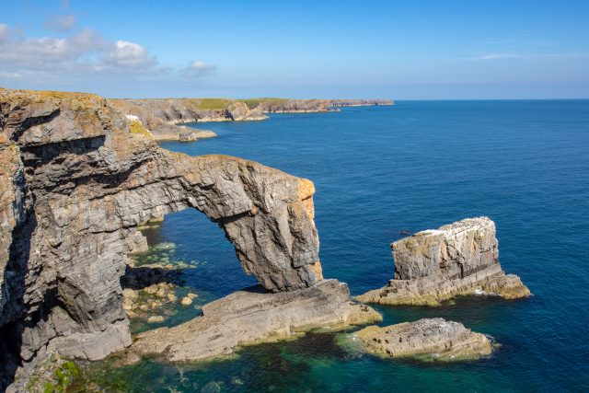
c=v
KS2 Performance!
We are so excited to be working on our performance of ‘The Jungle Book’ this term. The children will be practising lines, singing and preparing the staging for what is set to be a wonderful performance!
In English, we will be looking at ‘Journey’ by Aaron Becker a text driver for a variety of pieces of writing. This is a fabulous wordless story which takes you through the story of a little girl and her pen. We will be using this text as inspiration for own piece of fiction writing, based on using a range of techniques to describe the scene in depth and create an immersive experience for our readers.
In PSHE, we will be looking at ‘Changing Me’ which is all about changes within bodies during puberty, the idea of consent, physical attraction, conception, boyfriends and girlfriends etc. Year 5 and 6 will be taught some areas of this unit separately and our sessions will be very discussion based with children able to ask questions and be curious in a trusted environment.
In Science, our unit is Living Things and their Habitats, and we will look at life cycles of mammals, amphibians, insects and birds; describing the life processes in plants and animals; describing how living things are classified and will be discussing characteristics of plants and animals. We will also be learning about evolution as part of our science unit. We use White Rose Science resources alongside PLAN Science units and resources from Explorify to deepen our thinking.

Our Geography unit this term is Coasts, and we will be exploring what makes coastlines important. The children will learn about a variety of coastal processes and features, as well as how we can preserve our coastlines. We will also study popular coastal locations such as the Jurassic Coast (in particular Poole, Swanage and Old Harry’s Rocks). The children will explore enquiry questions through a variety of activities and conclude their own answer to the overarching question.
Coasts
Willow Class
Summer 2
Geography

Our PE this term is being taught by a specialist PE teacher and will involve learning about a range of team sports. This will follow our Complete PE curriculum and link to our events for the Burford Partnership. We are also looking at teamwork in a triathlon event.
In RE, we will be looking at the key question How do inspirational people impact on how Humanists live today?
The children will be discussing their own ideas around this question and looking at evidence to support their conclusions. Our RE units are generally discussion-based enquiry learning, with some whole class/individual recording into our class Big Book and individual RE books.
In Maths, we follow the White Rose Maths scheme of learning, and the children are encouraged to reason, and problem solve in every lesson. Both year groups are taught together and separately within the same lesson. This gives the children a proficient level of challenge as well as the opportunity for smaller group work. This term, Year 5 will be looking at decimals and measurement, whilst Year 6 will be undertaking a range of project-based tasks to consolidate their learning.

Key Question: Why are our coastlines important?

