Summer Term – Term 6 - Maple Class
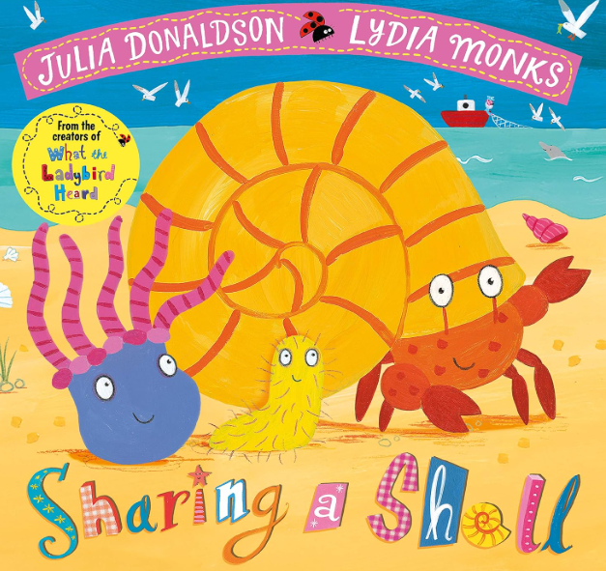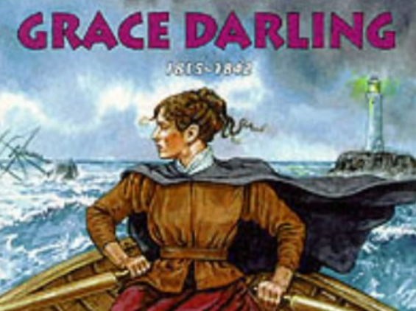
English – We will continue our daily phonics lessons (we have phonics screening w/c 8th June). Our focused text for this term is ‘Sharing a Shell’. We will be including a number of experience days within our English lessons to inspire children with this seaside-based text.
Whole Class Reading: In our whole class reading sessions we will be enjoying books linked to our English focused texts as well fact books to explore our History topic based on Grace Darling.
Maths- This term we will be focusing on Place Value (within 100), Measurement & Money & Time. The children will be exploring number through a wide range of enhanced provision-based activities as well as our whole class learning.
Science & DT– During the term we will caring for our plants, observing seasonal changes and learning about nutrition. We will harvest and cook our crops before the end of term.
History - Our focus this term is exploring the question ‘Why is Grace Darling remembered?’. As part of this topic, we will be exploring lighthouses and the seaside.
RE – In RE we will be exploring the question – Why is the story of the Buddha important to some Buddhists?
PSHCE – Our topic this term is ‘’Changing Me’. We will focus on life cycles, boys and girls’ bodies, learning and growing and coping with change.
PE – The children will be focusing on Athletics. We will start the term with a Quad Kids event at St Christophers – some children from Burford Primary will join us. This term we will run short and long distances, throw, jump and of course have fun at Sports Day!
Music – In music this term we will be focusing on composition, musicianship, singing and listening.
Computing – Our focus in computing this term is Programming Animations. We will have fun using Scratch and applying our mathematical and geographical knowledge!

