Spring Term – Term 4 - Maple Class
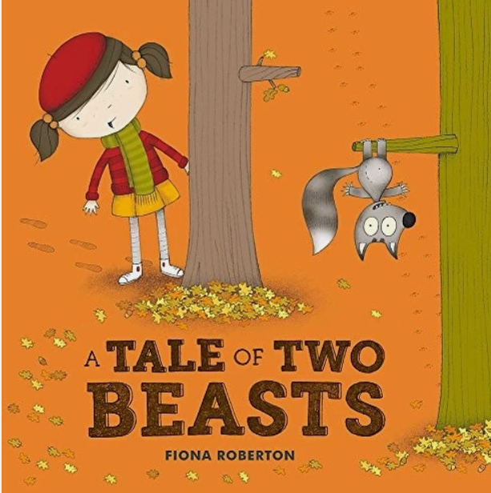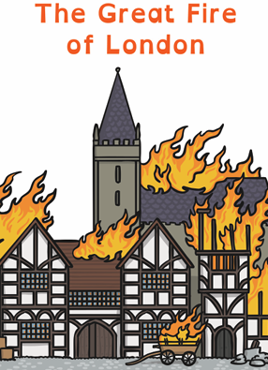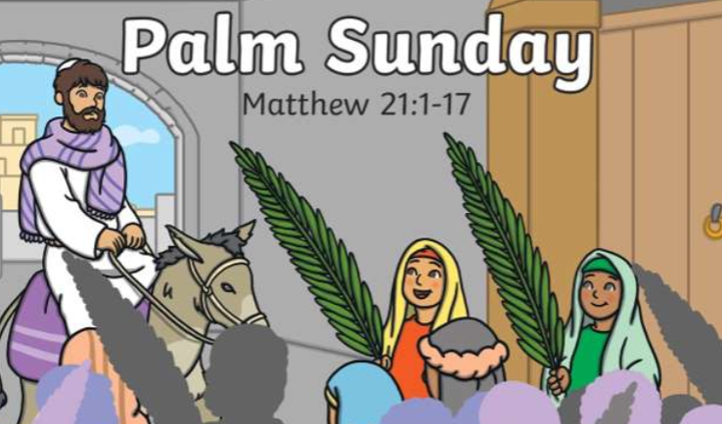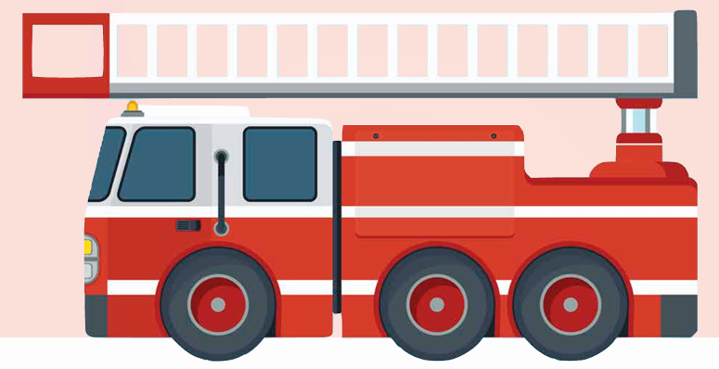
English – Our focused text for this term is ‘A Tale of Two Beasts’ by Fiona Robertson. We will be including a number of experience days within our English lessons to inspire children with their writing. We will also be enjoying other fairy tale books.
Whole Class Reading: In our whole class reading sessions we will be enjoying books linked to our English focused texts as well fact books to explore of History topic of The Great Fire of London.
Maths- This term we will be focusing on Place Value (within 50), length & height and mass & volume. The children will be exploring number through a wide range of enhanced provision-based activities as well as our whole class learning.
Science– During the term we will exploring animals including humans. We will be developing our knowledge of our senses and exploring our senses further. We will also be preparing our outside area for spring.
History - Our History focus this term is ‘The Great Fire of London’. We will be looking at how the fire started, what happened during the fire and how London changed after the fire.
DT – Linked to our History we will be making our own fire engines. In order to do this we will be learning about mechanical systems.
RE – In RE we will be exploring the question – Why was Jesus welcomed like a king or celebrity by the crowds on Palm Sunday?
PSHCE – Our topic this term is ‘Healthy Me’. This will have a focus on being healthy, medicine safety and road safety.
PE – The children will be focusing on ‘Health & Wrllbeing’, this links nicely with our PSHCE lessons. Please ensure your child’s PE kit is in school all week. We will also be visiting Forest School on a Wednesday, therefore your child will need long sleeved tops and bottoms as well as waterproofs for our outdoor learning.
Music – In music this term we will be focusing on ‘Exploring Sounds’. The children will be singing, playing instruments and composing music.
Computing – Our focus in computing builds upon our last learning sequence of programming as this term we will be learning how to group data.

