Autumn 1 | Autumn 2 | Spring 1 | Spring 2 | Summer 1 | Summer 2
Beyond My Window   | Night & Light   | Journeys  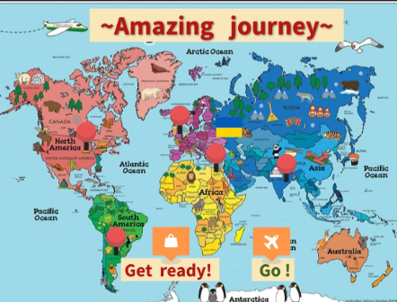 | Fire! Fire!   | Enchanted Woods   | Lighthouses  
    Skills Icons   | Skills Icons | 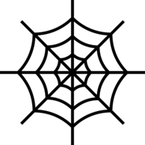  Skills Icons |   Skills Icons     | Skills Icons | Skills Icons
Subject Focus  Geography  EQ: What’s beyond my window? | Subject Focus  History  EQ: How Should we Commemorate the Moon Landing?  Why do we wear poppies? | Subject Focus  Geography  EQ: How far can we go? | Subject Focus  History  EQ: How should we rebuild London after the fire? | Subject Focus  Geography  EQ: Where could you find an enchanted forest? | Subject Focus  History  EQ: Why is Grace Darling remembered after 170 years have passed?
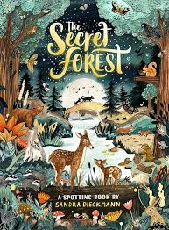 | 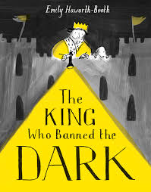 |  | 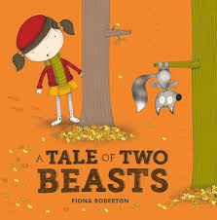 | 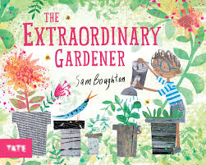 | 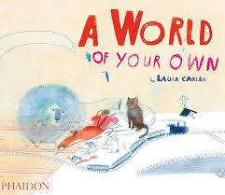
Trips  Batsford Arboretum | Trips  Panto | Trips | Trips  London | Trips | Trips  Whole School Poole/Swanage
Maths  See White Rose Maths |  | Maths  See White Rose Maths |  | Maths  See White Rose Maths
English  Write a set of interview questions for a visitor.  Create a fact file about our favourite British animal. | English | English | English | English | English
Other Learning  Science: Living Things and their Habitats (habitats for different living things)  RE: Is it possible to be kind to everyone all of the time?  PE: Attack +Defence  Computing: Computer Safety  ART: Spirals  PSHCE: Being Me In my World | Other Learning  Science: Materials  RE: Explore the meaning of Christmas, symbols and celebration.  PE: Gymnastics (linking)  Computing: Digital Painting  DT: Textiles  PSHCE: Celebrating Differences | Other Learning  Science: Living Things and their Habitats (plants + food)  RE: How do Jewish people celebrate key festivals?  PE: Dance (water)  Computing: Moving a Robot  ART: Print Marking  PSHCE: Dreams and Goals | Other Learning  Science: Animals including humans  RE: How important is it to Christians that Jesus came back to life after his crucifixion?  PE: Health & Wellbeing  Computing: Grouping Data  DT: Mechanical Systems  PSHCE: Healthy Me | Other Learning  Science: Plants  RE: What is the best way for a Buddhist to lead a good life?  PE: Rackets +bats  Computing: Digital Writing  ART: Playful Making  PSHCE: Relationships | Other Learning  Science: Animals including humans  RE: Does visiting the synagogue help Jewish people feel closer to God?  PE: Team Building  Computing: Programming Animations  DT: Cooking & Nutrition  PSHCE: Changing Me

