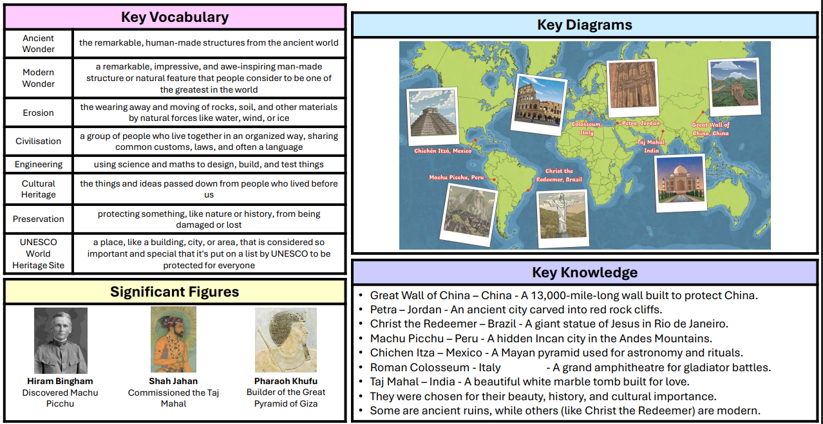

Oak Y3/4 Term 2

